Looking after your
Baby’s teeth

Parent and Carer Information

Health Visiting

Scan here for Health Visiting Services Webpage

Author ID: Health visiting team
Leaflet Ref: CM 043
Version: 3
Leaflet title: Looking after your baby’s teeth
Last review: July 2023
Expiry Date: July 2025

Introduction
Your baby’s first tooth comes through about the age of six months, but it can start earlier or later than this. It is important to protect your child’s first teeth against decay. Start brushing as soon as your baby’s first tooth appears. Brush your baby’s teeth last thing at night and one other time during the day. Use a smear of ordinary family fluoride toothpaste (1000-1450ppm). Fluoride helps to make teeth stronger.

Teething
Some babies may have teething troubles. It may help to:
- Give your baby something hard to bite on. A cooled, gel filled teething ring can help soothe the gums.
- Try using an infant teething gel or teething powders
- If necessary, use infant sugar free pain relief – always read the label.

Drinks
- Breast milk provides the best nutrition for babies.
- To keep your baby’s teeth healthy, choose breast milk, formula milk or plain, cool, boiled water.
- Using a cup is better for your baby's teeth. Introduce a free flow cup at around six months. Comfort sucking on a bottle can easily become a habit, so it is best to avoid this, as it can cause bottle caries (tooth decay). Aim to have your baby no longer drinking from a feeding bottle by their first birthday.
- A Doidy cup (Non-Spill Trainer Cup) is recommended for weaning babies.
- Never give your baby sugary drinks in a bottle or a valve type feeder cup, as this can cause tooth decay.
- Do not give your baby sugar free or diet drinks, as these are not recommended for young children.
- Avoid cordial/squash and all fizzy drinks - even the low or reduced sugar ones can damage your baby’s teeth.
- Fresh fruit juice can be given after six months; dilute one part juice to 10 parts water in a cup and serve only at mealtimes.

Food
- Sugar causes tooth decay. It is not just the amount of sugar in food and drinks that causes decay, but how often and long the teeth are in contact with sugar.
- Never add sugar to your baby’s food when introducing solid foods.

- Once your baby is having regular meals, keep anything sugary to mealtimes only.
- Make sure that any foods given are sugar free.
- Fresh fruit, cheese, toast, plain rice cakes are healthier choices.
- Dried fruits are very sugary and sticky and should be kept to mealtimes.
- There is hidden sugar in so many foods, so always ensure you check the food labels.
- Sugar is also known by the following names:
- Sucrose, glucose, maltose, fructose, dextrose, glucose syrup and honey.

Watch out for hidden sugars!

Dummies
If breast feeding, do not give a dummy until breast feeding is well established.
If your baby has a dummy, aim to stop using it by 12 months old.

Using dummies over the age of one year can affect the position of teeth. This may also stop babies from babbling, which is the first stage in learning to talk, and it may affect their speech development.

Never dip a dummy into anything sweet.

Sugar free medicines
- Always ask your doctor or pharmacist for sugar free medicines.
- Medicines that contain sugar can cause tooth decay.
- Medicines are often spread out over the day and may be given during the night.

Visiting the dentist
NHS Dental treatment for children is free. Take your baby to visit the dentist from an early age. This will help your baby to get used to the surgery and staff. A list of local dental practitioners is available from: https://www.nhs.uk/service-search/find-a-Dentist

Remember
- Brush baby’s teeth last thing at night, and one other time during the day.
- Choose milk and plain water for your baby.
- Reduce the amount of sugary foods and drinks given in a day and keep them to mealtimes.
- Always choose sugar free medicines.
- Visit the dentist regularly every 6 months.

Comments, Compliments or Complaints

The Patient Relations/Patient Advice and Liaison Service (PALS) Department provides confidential on the spot advice, information and support to patients, relatives, friends and carers.

Contact Us

Tel: 01942 822376 (Monday to Friday 9am to 4pm)

The Patient Relations/PALS Manager
Wrightington, Wigan and Leigh Teaching Hospitals NHS Foundation Trust
Royal Albert Edward Infirmary
Wigan Lane
Wigan WN1 2NN

Ask 3 Questions
Become more involved in decisions about your healthcare. You may be asked to make choices about your treatment. To begin with, try to make sure you get the answers to three key questions:

- What are my options?
- What are the pros and cons of each option for me?
- How do I get support to help me make a decision that is right for me?

How We Use Your Information

For details on how we collect, use, and store the information we hold about you, please take a look at our “how we use your information” leaflet which can be found on the Trust website: https://www.wwl.nhs.uk

This leaflet is also available in audio, large print, Braille, and other languages upon request.

For more information, please ask in the department/ward.

© Wrightington, Wigan and Leigh Teaching Hospitals NHS Foundation Trust.
All rights reserved. Not to be reproduced in whole or in part without the permission of the copyright owner.

Call 111 first when it’s less urgent than 999.

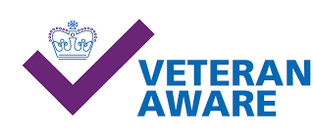
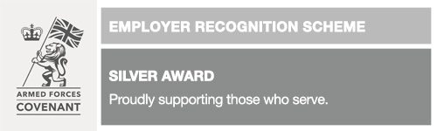
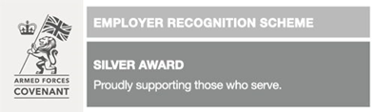
Phone: 0808 802 1212
Text: 81212
www.veteransgateway.org.uk

Phone: 0808 802 1212 Text: 81212
www.veteransgateway.org.uk
Phone: 0808 802 1212 Text: 81212
www.veteransgateway.org.uk

