**Accident & Emergency Department (Adults)**

**Royal Albert Edward Infirmary - Equality Engagement**

The Equality Delivery System (EDS) is a framework which was created by the Department of Health to help NHS Organisations to make improvements on equality, diversity and inclusion. To improve the services they provide for their local communities, consider health inequalities in their local area and provide better working environments free of discrimination.

**WWL want you, our service users and local community to have a say on our equality and inclusion work for A&E. We want to:**

* **Show you what we currently provide and what we are working on**
* **Ask you “are we getting it right for everyone / people from all protected characteristics?”**
* **Tell us how well you think we are doing - Score us on the following questions**

**When patients use the service, do they feel safe?**

(free from harm)

D **Can all patients (who need to) access the service?**

**Are patients reporting positive experiences?** take

**Are individual patient’s health needs being met?**

(receiving good care)

* 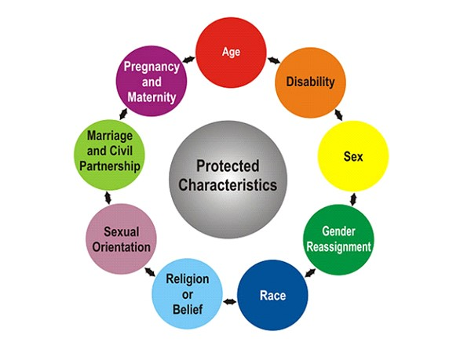**Help us decide what we need to do next.**

**Accident and Emergency Department (Adults) – What we provide**

The Emergency Department based at the Royal Albert Edward infirmary assesses and treats people with major trauma, serious injuries and those in need of emergency treatment.

It is open 24 hours a day, 7 days a week, 365 days of the year.

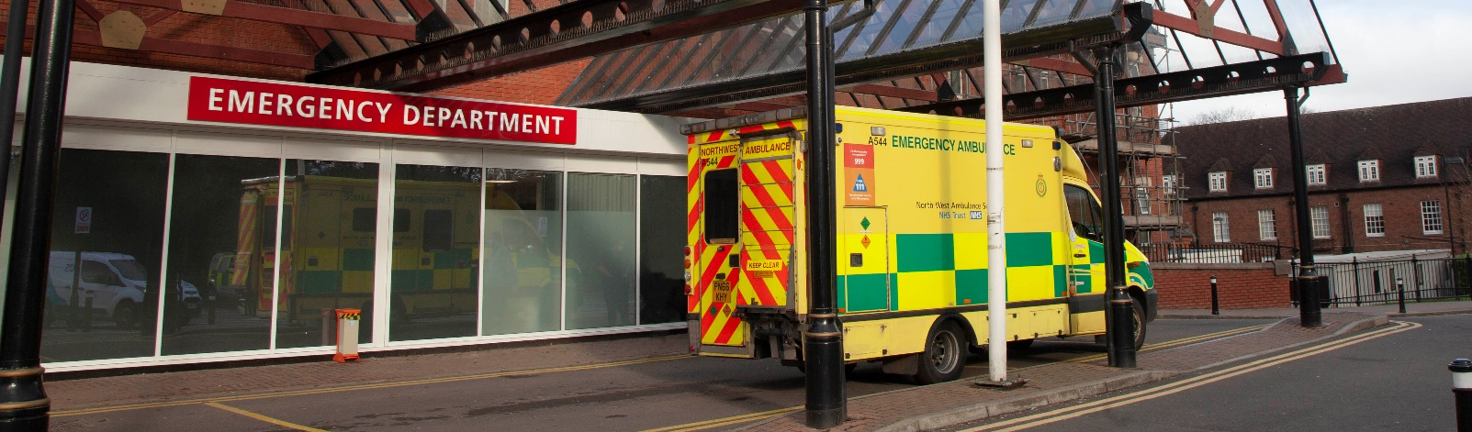

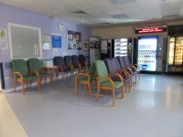

|  |
| --- |
| **Evidence 1: Can all patients (who need to) access to the service?** |

|  |  |
| --- | --- |
| **Protected Characteristic** | **Evidence on how each group can access this service** |
| **Sex**  (Male / Female) | **Unisex toilets only available for service users in A&E**  Unable to change the current provision of toilet facilities, due to space and the need to provide disabled toilet facilities. Separate Male and Female toilet facilities however available on hospital site. |
| **Transgender / Gender**  **Re-assignment** | **Guidance available for staff on supporting trans and non-binary patients.**  **Staff wearing Hello My Name is Badges with preferred pronouns.** |
| **Age**  **(18 years+)** | **Separate A&E Department for adults and children.** |
| **Race or Ethnicity** | **Access to interpreter and translation services.**   * Telephone interpreters available 24 hours / 7 days a week * Access to on demand BSL video remote interpreters (dedicated IPAD)   **Special dietary requirements catered for if required.**  **Access to Chaplaincy and Spiritual Care Team.**  **Multi-faith Chapel available in site.** |
| **Disability:**  Hearing Impairment | **Access to ‘on demand’ BSL video remote interpreters** (dedicated IPAD)  **Induction Loop in reception.**  **Pagers implemented for hearing impaired patients to alert them when they are being called.**  **A&E Booking In Form for hearing impaired patients implemented**. On arrival at A&E Reception, hearing impaired patients may have difficulty answering the receptionist’s ‘booking in’ questions. An ‘**A&E Form’** has been designed in collaboration with the local deaf community. Copies have been distributed and the local deaf community encouraged to complete, retain, then bring with them, when they attend A&E.  **Pictorial flash cards available on department** |
| **Disability:**  Visual Impairment | **Information / correspondence can be provided in braille, large print, audio on request.**  **Carers welcomed to be present with patient.** |
| **Physical Disability** | **Toilet and bathroom provisions accommodate disabled patients.**  **Carers welcomed to be present with patient.** |
| **Learning Disability** | **Access to Learning Disability Liaison Team**  **Pictorial flash cards available on department**  **Care bags available for patients in A&E (ear defenders / sensory toys)**  **Learning Disability Passport**  **Learning Disability Link Nurse regularly give tours for patients who have learning disabilities who may need access to services.**  **Carers welcomed to be present with patient.**  Currently no separate / quiet space available for patients to wait / be seen away from excess noise and activity. A sensory quiet space is being implemented in Paediatrics Emergency Department. Requirement to implement within Adults Emergency Department raised and will be reviewed within re-designed Emergency Department plans. |
| **Mental Health Need** | **Carers welcomed during patients stay.**  **Psychiatric Assessment Team based on site. Available 24 hours a day. Mental Health Streaming Area based in A&E.** |
| **Sexual Orientation** | **Department actively promotes LGBTQIA+ Events in A&E Waiting Areas.**  **Staff wearing Hello My Name is Badges with preferred pronouns.** |
| **Religion / Belief (please specify)** | **Access to Chaplaincy and Spiritual Care Team.**  **Multi Faith Chapel available on site.**  **Access to interpreter and translation services.**  **Special dietary requirements catered for.** |
| **Marriage & Civil Partnership** | **Department actively promotes LGBTQIA+ Events in A&E Waiting Areas.** |
| **Pregnancy & Maternity** | **Baby changing facilities available in A&E.**  **Breast Feeding Room available on site.** |
| **Carer Status** | **Access to Wigan Council’s Carer Support Team.**  ACTS can assist with supporting carers with their loved ones. |

|  |
| --- |
| **Evidence 2: Are all individual Patients health needs being met?** (having needs met in a way that works for them) |
| **Personalised Nursing Pathways and Risk Assessments**  Nursing pathways are plans that are put in place for patients. Some of these include prompts so referrals can then be made to other services which may be needed. Examples include: Safeguarding, Memory and Dementia Teams; Advanced Care Planning and Armed Forces Teams.  A Risk Assessment is a process which helps us to identify any patients who may be at risk of harm and helps us to reduce those risks through care planning and treatment. A&E Risk Assessments include the MUST Screening Tool; fall assessments; pressure ulcers; skin assessments and bed rail assessment. Depending on the outcome of these assessments, will depend on referrals to other speciality nurses. For example, if a patient scores on the MUST Screening Tool they are referred to the Dietician. |
| **Dementia/Learning Disability Passport ‘This is me’ in use** |
| **Equality Impact Assessment**  **An Equality Impact Assessment is undertaken on A&E every 3 years. Last Assessment undertaken May 2024.** We use this assessment to identify potential impacts, both positive and negative across all 9 protected characteristics, and look at how we could avoid disadvantage or further improve the delivery of our services.  To view a copy of our equality impact assessment please e-mail [EDI@wwl.nhs.uk](mailto:EDI@wwl.nhs.uk) |
| **Reasonable Adjustments**  We have introduced long-range pagers in the Emergency Department for hearing impaired patients who cannot always hear their name being called. We have also designed a dedicated form in collaboration with the local deaf community, which means that the local deaf community know what questions the receptionist is going to ask and can provide these on the form when they attend. Our Emergency Department also offer regular tours of the department for people with learning difficulties and their families so that they are familiar with the department in case they have to attend. A learning disability link nurse also participates in these visits and will work with patients with learning disabilities and autism if they need to attend for elective procedures or outpatient appointments. They can also produce bespoke paperwork for these patients to help them actively participate in their care and for patients with more complex needs, multidisciplinary planning meetings take place to reduce the likely distress of visiting the hospital. |
| **Other Examples of Reasonable Adjustments Made in A&E**    **Access to interpreter and translation services**  **Relatives / friends staying to provide emotional and physical support**  **Pictorial flash cards to help communication and understanding**  **Special dietary requirements catered for on request**  **Care Bags available for patients in A&E (ear defenders / sensory toys).**  **Use of RITA Entertainment System and Twiddle Muffs for dementia patients**  **Daily ‘Sparkle’ Newsletter for patients**  **Separate relatives room for private discussions** |

|  |
| --- |
| **Evidence 3: Are patients free from harm when they use the service?** (feel safe / there are procedures in place to ensure safety) |
| **Trust Risk Management Policy**  **All serious incidents / complaints are investigated, and lessons learnt embedded within Trust practice.**  All staff working in A&E have a role in identifying risk and ensuring children and adults are protected from harm. |
| **Safeguarding Team / IDVA (Independent Domestic Violence Advocate)**  Patients are assessed throughout the Emergency Care Centre journey for safeguarding/IDVA concerns.  We have a Safeguarding Link Team who work closely with the Safeguarding Team to distribute information and provide support. |
| **WWL Honour Based Abuse Procedure**  Honour-based Violence is abuse that is committed due to the belief an individual has brought shame or dishonour on their family or community.  Honour-based abuse may be physical or emotional. Honour-based abuse is illegal in the UK.  In the Emergency Care Department, we have processes in place to escalate concerns to the Safeguarding Team and follow appropriate procedures. |
| **Specific Emergency Care Department Pathways - Such as Frail Injured Patient Pathway (FRIP)**  The Emergency Care Department is a trauma unit. Due to our local demographics, we receive a lot of frail injured patients. We know there is an increased risk of trauma with frail patients, so we assess these patients with FRIP, a specific plan for treating frail injured patients. |
| **Actively work with system and community partners to improve safety outcomes for people, such as NWAS, AQUA** |
| **Actively encourages improvement culture through…Continuous Improvement Projects** |

|  |
| --- |
| **Evidence: Patients report positive experiences of the service** |
| The Trust collects and obtains feedback from patients through its PALS processes and patient surveys which are reported to the Trust Board of Directors. |
| **FFT Results – A&E Majors (Adults)**  The Friends and Family Test (FFT) is an important feedback tool that supports the fundamental principle that people who use NHS services, should have the opportunity to provide feedback on their experience.  The FFT asks people about their experience of services they have used and offers a range of responses.  **Feedback Scores received from 3,969 patients during Oct 2023 to Oct 2024**   |  |  |  |  |  |  |  |  |  |  |  |  |  |  |  |  |  |  |  |  |  |  |  |  |  |  |  |  |  |  |  |  |  |  |  |  |  |  |  |  |  |  |  | | --- | --- | --- | --- | --- | --- | --- | --- | --- | --- | --- | --- | --- | --- | --- | --- | --- | --- | --- | --- | --- | --- | --- | --- | --- | --- | --- | --- | --- | --- | --- | --- | --- | --- | --- | --- | --- | --- | --- | --- | --- | --- | --- | |  |  | **Star Rating** | | | | | | | |  |  |  |  |  |  |  |  |  |  |  |  |  |  |  |  |  |  | | | | | | |  |  |  |  | | | | |  | |  |  |  |  |  |  |  |  |  |  |  |  |  |  |  |  |  |  |  |  |  |  |  |  |  |  |  |  |  |  |  |  |  |  |  | |  |  |  |  |  | | |  | |  |  |  | | |  |  | |  | |  |  |  |  |  |  |  |  | | | | | | | | |  |  | | | | | | | |  |  |  |  |  |  |  |  |  |  |  |  |  |  |  |  |  |  |  |  |  |  |  |  |  |  |  |  |  |  |  |  |  |  |  |  |  |  |  |  |  |  |  |   **Positive:** 58% **Neutral:** 13% **Negative:** 29%   |  |  |  | | --- | --- | --- | | **Eligible Patients** | **Total Response** | **Response Rate** | | **23937** | **3969** | **16.6%** |      |  |  |  |  |  |  |  |  |  |  |  |  |  |  |  |  |  |  | | --- | --- | --- | --- | --- | --- | --- | --- | --- | --- | --- | --- | --- | --- | --- | --- | --- | --- | |  | | | | |  |  |  |  |  | | | | | | | |  | |  |  |  |  |  | |  | | | | |  |  |  |  |  |  | | | | | | | | |  |  |  |  |  |  |  |  |  |  |  |  |  |  |  |  |  |  | |
| **Urgent and emergency Care Survey 2022**  [Urgent and emergency care survey 2022 - Care Quality Commission (cqc.org.uk)](https://www.cqc.org.uk/publications/surveys/urgent-emergency-care-survey)  [**Wrightington, Wigan and Leigh Teaching Hospitals NHS Foundation Trust - Care Quality Commission**](https://www.cqc.org.uk/provider/RRF/surveys/30)  This survey looks at the experiences of people using type 1 and type 3 urgent and emergency care services. Type 1 services include A&E departments and may also be known as casualty or emergency departments. Type 3 services include urgent treatment centres and minor injury units. The survey only includes services directly run by an acute NHS trust.  **These are the results for Type 1 services.**  This survey looked at the experiences of 29,357 people who attended a Type 1 service in September 2022. Between November 2022 and March 2023, a questionnaire was sent to:   * 1,250 people who had used Type 1 services at trusts with no eligible Type 3 services, or * 950 people who had used Type 1 services and 580 people who had used eligible Type 3 services   Responses were received from 168 people at Wrightington, Wigan and Leigh Teaching Hospitals NHS Foundation Trust. |

|  |  |  |
| --- | --- | --- |
| **Theme** | **Patient Response**  **Out of 10** | **Compared with Other Trusts** |
| Arrival | **6.4** | About the same |
| Waiting Times | **3.7** | About the same |
| Doctors and Nurses | **7.6** | About the same |
| Care and Treatment | **7.1** | About the same |
| Tests | **7.1** | Somewhat worse than expected |
| Hospital Environment and Facilities | **8.3** | About the same |
| Leaving A&E | **6.0** | About the same |
| Respect and Dignity | **8.0** | About the same |
| Experience Overall | **6.9** | About the same |

|  |  |  |  |  |  |  |  |  |  |  |  |  |  |  |  |  |  |
| --- | --- | --- | --- | --- | --- | --- | --- | --- | --- | --- | --- | --- | --- | --- | --- | --- | --- |
|  | | | | |  |  |  |  |  | | | | | | | |  |
|  |  |  |  |  |
|  | | | | |  |  |  |  |  |  | | | | | | | |
|  |  |  |  |  |  |  |  |  |  |  |  |  |  |  |  |  |  |
|  | | | | |  |  |  |  |  |  |  |  |  |  |  |  |  |
|  |  |  |  |  |  |  |  |  |  |  |  |  |  |  |  |  |  |
|  | | | | | | | | | |  |  |  |  |  |  |  |  |

**Stakeholders Scores Table (See Scoring Guide below)**

|  |  |  |
| --- | --- | --- |
| **Outcome** | **Score** | **Comments** |
| **Can all patients (who need to) access the service?** Have equal access. |  |  |
| **When patients use the service, are they free from harm?** (feel safe / procedures in place to ensure safety) |  |  |
| **Are individual patient’s health needs being met?**  (having needs met in a way that works for them) |  |  |
| **Do patients report positive experiences?** |  |  |

**Scoring Guide**

|  |  |
| --- | --- |
| **Underdeveloped** | **Developing** |
| **SCORE 0 - Little or No Evidence**  **Sad face outline outline**  **People from all protected groups**  **Fare poorly compared to people**  **overall / No evidence** | **SCORE 1 - – Some Evidence 50%**  **Neutral face outline with solid fill**  **People from some protected groups**  **Fare as well as people**  **overall** |
| **Achieving** | **Excelling** |
| **SCORE 2 - Adequate Evidence 75%**  **Smiling face outline with solid fill**  **People from most protected groups Fare as well as people**  **overall** | **SCORE 3 - Extensive Evidence 98%**  **Winking face outline with solid fill**  **People from all protected**  **groups Fare as well as people**  **overall** |