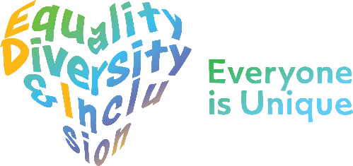


Myalgic Encephalomyelitis/ Chronic Fatigue Syndrome /
Long Covid Team Community Division - Equality Engagement

The Equality Delivery System (EDS) is a framework which was created by the Department of Health to help NHS Organisations to make improvements on equality, diversity and inclusion. To improve the services they provide for their local communities, consider health inequalities in their /local area and provide better working environments free of discrimination.

WWL want you, our service users and local community to have a say on our equality and inclusion work for ME/CFS/LC/Long Covid Team We want to:

- Show you what we currently provide and what we are working on
- Ask you “are we getting it right for everyone / people from all protected characteristics?”
- Tell us how well you think we are doing - Score us on the following questions
- Help us decide what we need to do next
When patients use the service, do they feel safe?
(free from harm)
D Can all patients (who need to) access the service?

Are individual patient’s health needs being met?
(receiving good care)
Are patients reporting positive experiences? take

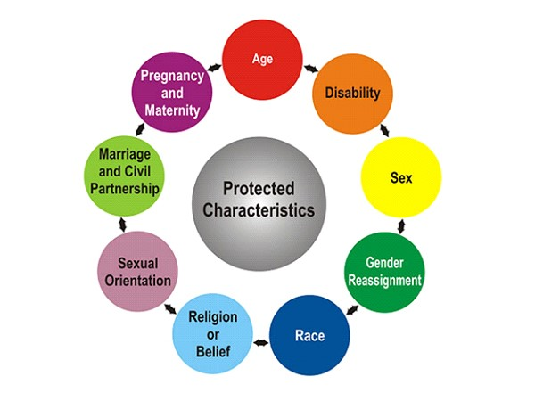
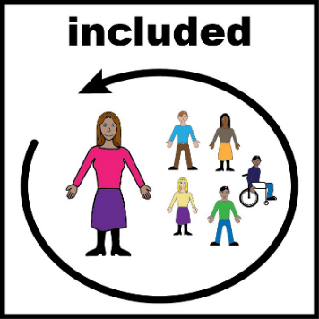

Myalgic Encephalomyelitis(ME) / Chronic Fatigue Syndrome (CFS) /
Long Covid Team Community Division
The ME / CFS / Long Covid Specialist Multi-disciplinary Team are based in the Community Division of Wrightington, Wigan and Leigh Teaching Hospitals NHS Foundation Trust.
Referrals are accepted for presenting symptoms of fatigue.as per NICE guidance lasting for a duration of 4 months, worsening after periods of exertion and unrelieved by rest with other medical causes ruled out.
The team which includes a Rehabilitation Medicine Consultant, Physiotherapists, Occupational therapists and admin, are based at Golborne clinic. They provide initial diagnosis followed by therapeutic intervention in the form of one to one and/or group support. They offer clinic appointments, telephone appointments, home visits and virtual appointments via Attend Anywhere in accordance with patient need.

Golborne Clinic
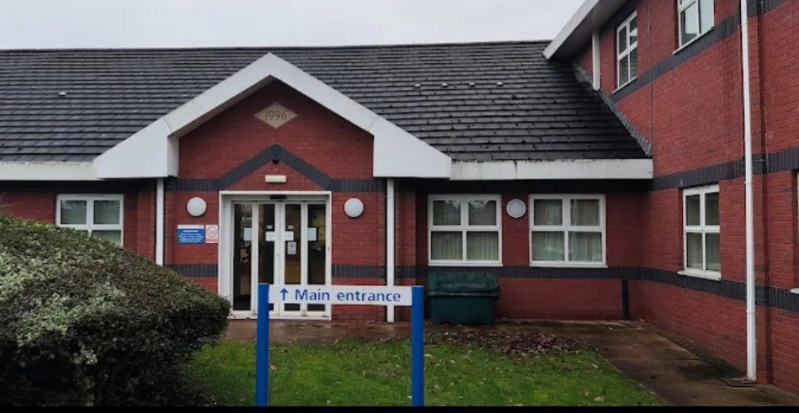

Evidence 1: Can all patients (who need to) access to the service?

Protected Characteristic | Evidence on how each group can access this service
Sex  (Male / Female) | Single sex toilets available at Golborne Clinic  Patients have equality of opportunity to access the service in relation to health irrespective of whether they are male, female, single, divorced, separated, living together or married.
Transgender / Gender  Re-assignment | Guidance available for staff on supporting trans and non-binary patients.  The ME/CFS/LC Team provide equal opportunity in relation to health care for individuals irrespective of whether they are male or female, trans or ‘whether they identify with the gender they were assigned at birth’.  The team understands and the maintains confidentiality about an individual’s trans identity / history.
Age  (18 years+) | The service is for adults over 18 years.  Children would be referred to Paediatrics – The service does accept transitional patients at the request of the referring clinician /GP if deemed appropriate.
Race or Ethnicity | Access to interpreter and translation services.  We have full access to interpreter and translation services for patient’s relatives/carers from different ethnicities who do not speak English as their first language.  WWL provides access to the following interpreter and translation services:  - Face to Face and telephone interpreters  - British Sign Language Interpreter (face to face and video remote on demand
Disability:  Hearing Impairment | Access to British Sign Language Interpreters  (face to face and video remote)  Portable hearing loop available in Golborne clinic and microphones at reception to enable staff and patients to hear each other due to the screens.
Disability:  Visual Impairment | Information / correspondence can be provided in braille, large print, audio on request.  Provision of additional support available.  (recorded within individual notes on system one)
Physical Disability | Toilet provisions which accommodate disabled patients are available in Golborne clinic.  Access to the clinic – clinic is on one floor and has designated parking facilities for disabled patients. Golborne clinic was chosen as a central location in the borough for ease of access for patients. Staff undertook a review of the waiting area and create their own space for patients to facilitate patient needs due to the nature of ME/CFS/LC
Learning Disability | Access to Learning Disability Team and carer support available.  Patient information can be obtained in easy read format / large print.
Mental Health Need | The service provides an in-depth triage process in which accommodations for any mental health need can be discussed before accessing the service e.g. virtual assessments, home visits, named clinicians and availability of chaperone.  One to one or group session are offered based on individual needs.  We always endeavour to promote links with Local Mental Health services and complete joint working with the counselling and talking therapies service.
Sexual Orientation | The ME/CFS/LC Service recognises and respects individual’s sexuality and the right of maintenance of confidentiality about an individual’s sexuality, this is recorded on system one if the patient consents to share this information.
Religion / Belief (please specify) | Access to interpreter and translation services.  ME/CFS/LC Service recognises and respects individual’s religion and beliefs and this is recorded on system one if the patient consents to share this information.
Marriage & Civil Partnership | The ME/CFS/LC Team provide equal opportunity in relation to health care for individuals irrespective of whether they are single, divorced, separated, living together or married or in a civil partnership. This is recorded on system one if the patient consents to share this information.
Pregnancy & Maternity | The ME/CFS/LC Team provides equality of opportunity in relation to health care for women irrespective of whether they are pregnant or on maternity leave or breast feeding.  Golborne Clinic provides baby changing facilities.
Carer Status | Access to Wigan Council’s Carer Support Team.  The team will provide flexibility of appointment times to accommodate carer responsibility. This is recorded on system one if the patient consents to share this information.

Patients across all groups have equal access to the service and at present the service has representations across all groups.

Evidence 2: Are all individual Patients health needs being met? (having needs met in a way that works for them)

Patients report they feel listened to and understood which underpins a feeling of safety. The service ensures all possible procedures are put in place at all times.

Personalised Individual Care Plans
All patients have a personalised individual care plan.

If a need/adjustment in relation to a patient’s protected characteristic is required, then this is considered when the patient is admitted onto the caseload.
All needs / care plans are reviewed at each patient contact.
Weekly MDT meeting
Staff meet weekly to discuss individual patients who require more complex intervention and have access to a regional Tier 4 pathway in Salford for clinicians to present very complex patients with access to a range of specialist consultants.

Equality Impact Assessment

An Equality Impact Assessment is undertaken on ME/CFS/LC every 3 years. Last Assessment undertaken July 2025. We use this assessment to identify potential impacts, both positive and negative across all 9 protected characteristics, and look at how we could avoid disadvantages or further improve the delivery of our services.

To view a copy of our equality impact assessment please e-mail EDI@wwl.nhs.uk

Evidence 3: Are patients free from harm when they use the service? (feel safe / there are procedures in place to ensure safety)

The service ensures all possible procedures are put in place at all times to ensure patient feel safe and free from harm.

Trust Risk Management Policy

All serious incidents / complaints are investigated, and lessons learnt embedded within Trust practice.
All staff within the ME/CFS/LC Team have a role in identifying risk and patients are protected from harm.
Personalised Individual Care Plans
All patients have a personalised individual care plan.

If a need/adjustment in relation to a patient’s protected characteristic is required, then this is considered when the patient is admitted onto the ME/CFS/LC caseload

Links with Safeguarding Team
Staff have completed safeguarding training and are aware of how to access WWL and council safeguarding teams

Links with Independent Domestic violence Advisor (IDVA) Nurses

ME/CFS/LC Team members have received awareness training on domestic violence and know how to refer to IDVA Nurses.

Evidence: Patients report positive experiences of the service

Patient feedback

The Trust collects and obtains feedback from patients through its PALS processes and patient surveys which are reported to the Trust Board of Directors

A GM wide patient satisfaction survey for ME/CFS/LC services is currently part of the ongoing ICB review of services and under development.

FFT Results
The Friends and Family Test (FFT) is an important feedback tool that supports the fundamental principle that people who use NHS services, should have the opportunity to provide feedback on their experience.
The FFT asks people about their experience of services they have used and offers a range of responses.
No family friendly results available at present but below are some recent patient compliments:
Patients report positive experiences around patient care but are often disappointed by the waiting time to receive the treatment.
Sample of some of the positive feedback received:
Transgender patient:
I feel I have been treated very well by the service. The clinic environment feels safe for me, all members of staff at reception and from the clinic are kind and friendly. I also appreciate the comfortable seats in the waiting area, and the water and tissues available in the clinic room.

Patient requiring an interpreter:
I think the service is very good. They organise telephone interpreters in my language for every visit and give me extra time for my appointment to help me. They understand my culture and the problems I have had. I am very happy with this service.

Patient:
Thank you so much. Your emails are such a huge comfort. To know you are there to ask and receive advice. So much appreciated.

Patient:
Thank you so much for the letters they are brilliant what a star. 🩷

A Patient’s Story: My Recovery Journey

I became ill with long Covid early on in the pandemic, at a time in my life when I was under huge physical and mental demand. I had a toddler and a small child, there was no childcare available, I was expected to home school my 5 year old, I was still breastfeeding and being woken in the night, my work was necessary to the functioning of the NHS, my husband was a front line worker. There was no place or space to rest and convalesce, and no help from the NHS. When I look back I see how I had pushed myself for years to function at a high level, putting everything and everyone else before my own needs.

After 7 months of spending almost all of my time alone in bed with long covid, on Christmas Day, listening to my children downstairs playing and celebrating whilst I lay in bed exhausted, door closed and curtains drawn, I broke down. And expending all that emotional energy cost me so much that I relapsed, a relapse that took me two years to pull myself out of.
During that time I became bedbound, being wheeled to the toilet and eating food just a few minutes at a time whilst lying down, sometimes being spoon fed. My mind was foggy, I couldn’t engage my brain for more than few minutes at a time before it shut down.

For the next 18 months I was up and down. I had severe anxiety and every single symptom and noise made me ruminate and panic. I woke up every day in the early hours with fear literally raging up and down my body, I would stay in freeze mode, still as a statue, too scared to move, staring at the wall trying not to think, waiting for my husband to wake was absolute torment, and as soon as he woke I would say the same thing every day ‘ I cant take this anymore, I’m so desperate for it to stop, but there is no way out.’ I became severely depressed. I objectively believed I was no more worthy than a broken toy and that I needed to be thrown in the bin. I gave the illness a personality, saw it as an evil force to be feared. I have never experienced such emotional torment, I felt oppressed. There were some improvements, but the emotional energy being spent meant that overall I was spiralling down. I felt as though the walls were closing in on me. I believed I would never get better, only worse until there was nothing left of me, and that terrified me. I could see it, and recognise what was happening to me, but I was so unable to control my symptoms, emotions and energy that I couldn’t stop it from happening.

For 18 months I didn’t get a wash of any kind, except for my hands once a day. I changed my pyjamas once a month and needed help to dress, I gave up on underwear. My hair became so matted I cut it off – it took me a week to cut it all off, one cut a day, exhausted by lifting my arms more than once. My husband encouraged me to wash but I declined – he offered to lift me into the bath or shower – he didn’t understand that even with help I would expend energy, that I couldn’t tolerate temperature change, that I didn’t want to expose my wasted body. I didn’t have the energy to explain these things – I just said ‘no’. I was judged for my lack of hygiene, it made me feel ashamed, but they had no understanding of how energy intensive personal hygiene is, and how scary it is to spend energy, knowing that unbearable consequences could follow.

I had a bed, and a box next to the bed with a few belongings, and that was pretty much my life.
The hardest thing was being removed from my children’s lives, not knowing them anymore, not caring for them despite the instinctive knowing that I should be, lying in bed whilst their birthday parties went on downstairs, needing my husband to interpret my toddlers sentences and hand gestures for me - a unique toddler language that I should have known as if it were my own. We had just minutes together twice a day – once in the morning and once at bedtime and all my waking hours I would be looking forward to this. But sometimes they could take me or leave me, I wasn’t their favourite person anymore, and this really hurt. Outside of these planned times, when I had no energy, they might come running into my room to tell me something or just to be with me, and within minutes would exhaust me physically and cognitively – and so I began to fear them. I couldn’t bear to reject them and so I engaged with them and so my symptoms worsened. If I did reject them the sadness that comes with that was also exhausting – there was no way out of it. So I began hiding in the walk-in-wardrobe – lying down in there with a pillow and blanket. I asked my husband to put a lock on the door, and only once I was inside with the door locked did I feel truly safe from the world. We told the children that I was at the doctors where they had a special resting bed that would make me better. I hid in the wardrobe for just over a year and a half. My children would come to look for me regularly shouting ‘mummy are you home yet?’, but I could breathe freely knowing they couldn’t ‘hurt’ me and I wouldn’t have to reject them.

When I started to improve, in the evenings when my energy was typically at its highest, my husband would lift me out of the wardrobe and put me into bed, my children would come running to me as soon as they heard and we would have four precious minutes together, then five, then six, then more. All day I would hold that at the forefront of my mind, knowing that if I rested and rested something good would come. One day they made a picture for me and my husband stuck it on the ceiling in my bedroom for me to look at whilst I lay down, this gave them such joy that within a matter of weeks my bedroom walls were full of their pictures. And in every family picture they made I was there with them, not lying down but standing up just as I should have been.

People around me tried to help but their version of helping was unhelpful. My mum in particular was very hard on me, saying ‘just get yourself moving’ and ‘I know you’re in a dark place but you have to start trying, if not for yourself then for your children - they need you and so do I’. It felt like emotional blackmail, maybe that’s harsh. She would direct her anger and frustration at me, as if I was bad, and then I would feel guilty, ashamed, anxious. She would come to me crying saying ‘this is killing me’, and I would feel so sad for her, but also angry at her for making me feel worse. I would say ‘I can’t cope with your emotions as well as my own, you need to find someone else to talk to’, but she ignored this, I think she thought if I could see how hard it was for her I would ‘get myself moving’ and get better. My husband would try to encourage me by saying things like ‘you just need to stop caring’ and ‘it’s all in your head, just take that extra step’. Not being understood or believed is incredibly draining and miserable and ultimately perpetuated my symptoms. I cut my mum off, hiding under the covers whenever I heard her footsteps on the stairs. I WAS trying, trying my absolute best, but ultimately, I just didn’t know how to help myself, nor did I have any energy to figure it out. I was judged, disbelieved, talked about in earshot – it only worsened the isolation and anxiety. I think disbelieving my reality was their coping strategy and I forgive them. Despite their negativity, without their support I never would have had a chance at getting better either.

During this time I leaned on my husband for literally everything, as did the children, and he suffered because of it. But he kept going, kept feeding me, caring for the children, speaking on my behalf, working, sitting with me whenever he had a chance. My mother in law cleaned the house, did all the family organising, and she believed in me. She was the only one who ever said to me ‘this is not your fault, you didn’t ask to be ill or want to be ill, but you’ll get better.’ My mum helped a lot with the children and the cooking, and still does.

We did try to find emotional support but because I could not engage in conversation well it was hard to find. I also paid privately to work with a psychiatrist and tried many medications, and the side effects and disappointments were hard to bear. It took a year and a half of trying medications to finally settle on a combination and dosage that helped my mood. And around the same time, after around 2years of being ill, an Occupational Therapist at the Chronic Fatigue Service Clinic did a course of DBT with me via email, I had enough energy to read 1 page a week, and bit by bit I implemented the techniques and saw improvements.

A few months later I started an online course named ‘ANS Rewire’. After another six months or so the course had had such an effect on me that I was able to do timeline therapy with the Chronic Fatigue Service Clinic. I do believe it was a combination of these four things that propelled me forward on my healing journey. And this makes me firmly advocate for online support, in the form of a course, as well as some specialised help, would help those with severe symptoms to be able to recover, one sentence or one minute at a time, until the techniques become habits and their energy snowballs to a point where they can engage in face to face help.

In the initial stages of the illness when I searched the internet for help, the overwhelm was incredible. There are so many differing theories, so much money that one could spend seeking a cure, and so much hopeless and helpless information. Another reason for the need to have an NHS badged online course, to avoid the overwhelm and expense that comes with seeking help.

For a long time I believed that when I got better I would go and find my toddler and six year old and give them big hugs and take them out for a walk with the pram. But the pram and those children were long gone. But still I believed I would somehow go back in time. I had to grieve for my children and come to a place of acceptance. It was a difficult journey made possible by spending increasing amounts of time with my children at the age they are. I sometimes feel like I have four children – the two little girls that I lost and the two bigger girls that replaced them. But this feeling comes to me less and less over time as I heal. When I look at photos of them taken during the years I spent in bed I become disoriented – I don’t recognise their faces, clothes or shoes, I don’t know what age they were, it makes me panic. I avoid doing it, for now.
I did not deserve to be ill and my children did not deserve to lose so much of me.

I still cannot lay my head flat, vertigo was my worst symptom and is still my biggest fear. I avoid closing the bedroom door in the day or getting under the covers in the daytime. I still have stubborn trauma symptoms relating to the illness and I am working on these all the time.
I’ve had to change many things such as tackling perfectionism, people pleasing, low self esteem, but also to finally tackle longstanding trauma issues and anxiety disorders. The more I work on my emotional health, mindfulness, brain rewiring, routines and habits, the better I become.

I’m now making up for lost time with my children and working on being able to work again. I even know now that I can fully recover. I also know now what the most important things are to me – the things I started to add back into my life when I was able to function again such as brushing my teeth twice a day and reading to my children. And things I will never ever add back in such as excessive cleaning, excessive checking, worrying about things outside of my control, perfectionism. When you lose your physical and cognitive functioning and have to rebuild your life from scratch you get to prioritise and rebuild it in the best possible way. I’m not glad I’m ill, but I’m not sorry either – I could never have the perspective nor be the person I am today without it. I love my life and myself more than I ever have. Severely affected people are an emergency, even though we aren’t seen that way, we are, and there is a way for us to get better.

Stakeholders Scores Table (See Scoring Guide below)
Outcome | Score | Comments
Can all patients (who need to) access the service? Have equal access.

When patients use the service, are they free from harm? (feel safe / procedures in place to ensure safety)

Are individual patient’s health needs being met?
(having needs met in a way that works for them)

Do patients report positive experiences?

Scoring Guide

Underdeveloped | Developing
SCORE 0    People from all protected groups  Fare poorly compared to people  overall / No evidence | SCORE 1    People from some protected groups  Fare as well as people  overall
Achieving | Excelling
SCORE 2    People from most protected groups Fare as well as people  overall | SCORE 3    People from all protected  groups Fare as well as people  overall

