


COPD, Royal Albert Edward Infirmary - Equality Engagement
The Equality Delivery System (EDS) is a framework which was created by the Department of Health to help NHS Organisations to make improvements on equality, diversity and inclusion. To improve the services they provide for their local communities, consider health inequalities in their local area and provide better working environments free of discrimination.

WWL want you, our service users and local community to have a say on our equality and inclusion work for COPD Unit. We want to:

- Show you what we currently provide and what we are working on
- Ask you “are we getting it right for everyone / people from all protected characteristics?”
- Tell us how well you think we are doing - Score us on the following questions
- Help us decide what we need to do next
When patients use the service, do they feel safe?
(free from harm)
D Can all patients (who need to) access the service?

Are individual patient’s health needs being met?
(receiving good care)
Are patients reporting positive experiences? take

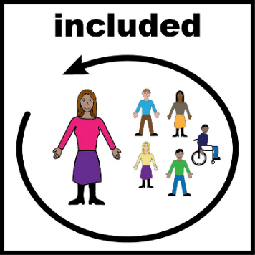

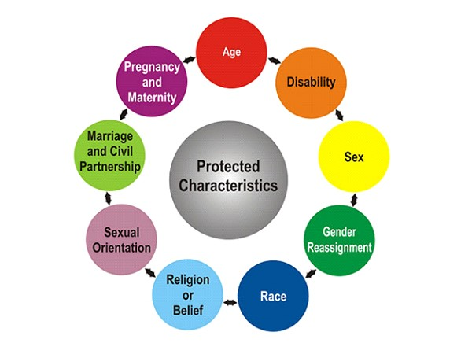

Chronic Obstructive Pulmonary Disease (COPD) Unit
Royal Albert Edward infirmary –

We provide a one stop, same day assessment service for confirmed COPD patients who are experiencing an exacerbation.
The assessment may include blood tests, chest xray, ECG, Spirometry or a combination of these.
After assessment you may be offered a 2 week monitoring period of home visits and telephone call. A 6 week clinic may also be offered.
The service also offers COPD Specialist Nurse Led Clinics and
Consultant Clinics.

We also provide a full Oxygen Assessment Service
We offer a COPD/Oxygen Support Group monthly off site at Tesco Leigh
(Last Wednesday of month)

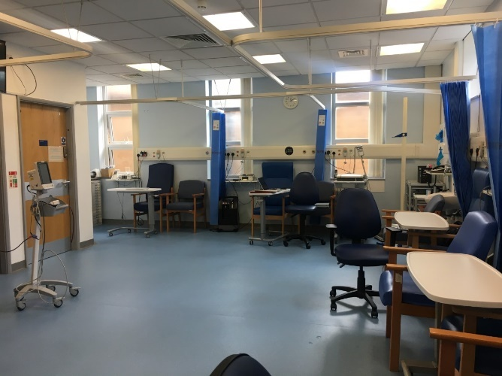
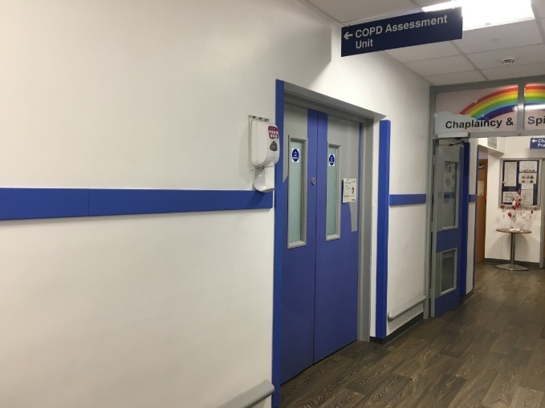

Evidence 1: Can all patients (who need to) access to the service?

Protected Characteristic | Evidence on how each group can access this service
Sex (Biological)  (Male / Female) | Unisex toilets available.  Curtains to separate male and female patients.
Transgender / Gender  Re-assignment | Unisex toilets available.  Curtains to separate male and female patients.  Staff ask patients for their preferred pronouns  Guidance available for staff on supporting trans and non-binary patients.
Age  (18 years+) | COPD is an adult disease (normally affecting patients over 35 years of age.
Race or Ethnicity | Access to interpreter and translation services.  We have full access to interpreter and translation services for patient’s parents/relatives/carers from different ethnicities who do not speak English as their first language.  WWL provides access to the following interpreter and translation services:  - Face to Face and telephone interpreters  - British Sign Language Interpreter (face to face and video remote on demand)  Special dietary requirements catered for on the Unit if required (would liaise with Kitchen Staff).  Access to Chaplaincy and Spiritual Care Team. Prayer Room available in site.
Disability:  Hearing Impairment | Disability considered as part of risk assessments / care plans for Oxygen and COPD (recorded in notes) / Provision of additional support available  Access to British Sign Language Interpreters  (face to face and video remote)  Written instructions can be provided if required.  Unit can be quite noisy at times, so patient can be moved into a quieter area if required (chapel / office)  Carers encouraged to accompany patient when attending unit.
Disability:  Visual Impairment | Disability considered as part of risk assessments / care plans for Oxygen and COPD (recorded in notes) / Provision of additional support available  Information / correspondence can be provided in braille, large print, audio on request.  Carers encouraged to accompany patient when attending unit.
Physical Disability | Disability considered as part of risk assessments / care plans for Oxygen and COPD (recorded in notes) / Provision of additional support available  Toilet and bathroom provisions accommodate disabled patients.  Provisions in place to accommodate patients who are physically disabled. Including adaptive chair spaces to accommodate wheelchairs and mobility scooters.  Access to bariatric services  Provision of additional support available  (recorded within individual care plan).
Learning Disability | Disability considered as part of risk assessments / care plans for Oxygen and COPD (recorded in notes) / Provision of additional support available  Carers encouraged and welcomed to accompany patient.  Access to Learning Disability Team.  Patient information can be obtained in easy read format / large print.  All staff have attended Oliver McGowen Training.  Pre- screen appointments can be provided if required to facilitate a quieter environment.  Access to ear defenders if required.
Mental Health Need | Carers welcomed during patients stay. Provision of additional support available.  Access to RAID Team.  Access to Talking Services.  Access to Addiction Services.  Access to Chaplaincy and Spiritual Care Team (close working relationship)  Staff in Unit from varied backgrounds (have extensive knowledge / previous experience of mental health needs). Not restricted to time constraints – can adapt length of patient’s assessment, dependant to their individual needs. This is explained at the beginning of the patient’s assessment, to help alleviate any anxieties and fears.
Sexual Orientation | Unit Ward actively promotes LGBTQIA+ Events (including Wigan Pride – Annual Event)  Staff ask patients for their preferred pronouns  Unit Staff have an awareness of Equality, Diversity and Inclusion and are respectful of everyone.
Religion / Belief (please specify) | Access to Chaplaincy and Spiritual Care Team. Prayer Room available in site. Staff aware of prayer times.  Access to interpreter and translation services.  Special dietary requirements catered for if required.  Curtains to separate male and female patients / maintain privacy.  Religion / Faith recorded in notes and factored within care plan.
Marriage & Civil Partnership | Ward actively promotes EDI Events (including LGBTQIA+) – Display Board on Unit promoting monthly EDI events / celebrations,
Pregnancy & Maternity | Individualised Care Plans – to date the Unit has never had to care for a pregnant patient (this could be due to the COPD / Oxygen patients being of an older age range).  Breast Feeding Room and baby Changing facilities available on site.
Carer Status | Access to Wigan Council’s Carer Support Team and Community Link Workers.  COPD Support Group – Open to patients and carers as and when they would like to attend. Based in Tescos, Leigh. Meetings held monthly.

Evidence 2: Are all individual Patients health needs being met? (having needs met in a way that works for them)

Personalised Individual Care Plans
All patients have a personalised individual care plan.

If a need/adjustment in relation to a patient’s protected characteristic is required, then this is considered when the patient is cared for on the COPD Unit.

For Example:
- Learning Disability Team asked to support patient with learning disability during assessment.

- One patient when becomes tired, uses sign language – For clinical discussions, video remote and face to face BSL interpreters is then used. Two members of staff have learned basic British Sign Language for social interaction purposes. This was appreciated by the patient and has helped develop confidence and trust in the service.

- Patient’s religion / faith recorded in notes and factored in to care plan.

Equality Impact Assessment

An Equality Impact Assessment is undertaken on COPD every 3 years. Last Assessment undertaken June 2024. We use this assessment to identify potential impacts, both positive and negative across all 9 protected characteristics, and look at how we could avoid disadvantage or further improve the delivery of our services.

To view a copy of our equality impact assessment please e-mail EDI@wwl.nhs.uk

Evidence 3: Are patients free from harm when they use the service? (feel safe / there are procedures in place to ensure safety)

Trust Risk Management Policy

It is Trust Policy for all serious incidents / complaints to be investigated, and lessons learnt embedded within Trust practice.
All staff working in the COPD Department have a role in identifying risk and ensuring children and adults are protected from harm.
Personalised Individual Care Plans
All patients have a personalised individual care plan.

If a need/adjustment in relation to a patient’s protected characteristic is required, then this is considered when the patient is cared for on the COPD Unit.
Lessons Learned from Incidents embedded within everyday activity

Received feedback from a patient recently, advising that he felt safe discussing his sexual orientation, which he has never discussed previously in a healthcare setting for fear of receiving poor care.

Evidence: Patients report positive experiences of the service

Patient feedback

The Trust collects and obtains feedback from patients through its PALS processes and patient surveys which are reported to the Trust Board of Directors

No formal complaints in relation to COPD have been received.
During October 2025 a Patient Experience Survey was undertaken in the COPD Department.
31 patients participated in this survey. Feedback showed that patients are reporting positive experiences when using the COPD Service. Results shown below:

All patients who participated in the survey, reported a ‘very good’ and ‘good’ experience.

The reasons why these scores were given are listed below:
COPD is amazing. Always a phone call away for advice and always able to come to COPD for a full assessment. Feel reassured with my mum.

All staff lovely. Very helpful!

They are brilliant

Excellent staff. Given lots of time to discuss.

Excellent staff, communication and service

Friendly staff. No waiting
Nurses always helpful and look after patients - delays due to consultant delay
Staff very attentive and helped alleviate my anxieties, ensured comfortable during stay
Very professional staff, knowledgeable & friendly / well informed of every procedure
Friendly staff - could not do enough
Staff lovely

Helpful staff and friendly

Friendly staff. Drinks and food offered. Relatives welcome. Plenty time to talk
staff attentive and helpful
Excellent staff. Very informative and extremely helpful. COPD had reduced my time spent sitting in A&E awaiting treatment. Exceptional service. Staff always pleasant, patient and helpful.
Made to feel comfortable. All staff pleasant and explained everything well
Thorough explanations about condition. Friendly supportive staff. Informed about steps for the future. Very professional approach.
Attentive and polite staff. Explain everything / Marvelous team! Friendly and efficient staff
Friendly staff attitude. Good treatment. No waiting to be seen. Great staff!
Friendly and professional staff. Made to feel at ease. Everything explained clearly
Always treated well

Very efficient

Staff extremely efficient, friendly & knowledgeable

Very happy with service. Staff lovely!

When Patients were asked how they could make their experience better
No patients recommended any improvements – All were happy with the service provided.

Patient Demographics:

Longstanding Illness | 5
Sensory | 1
Physical | 5
Mental Health | 1

Ethnicity
All patients who participated in survey were of British White Ethnicity

Sexual Orientation
All patients who participated in survey declared that their sexual orientation was Heterosexual

Stakeholders Scores Table (See Scoring Guide below)
Outcome | Score | Comments
Can all patients (who need to) access the service? Have equal access.

When patients use the service, are they free from harm? (feel safe / procedures in place to ensure safety)

Are individual patient’s health needs being met?
(having needs met in a way that works for them)

Do patients report positive experiences?

Scoring Guide

Underdeveloped | Developing
SCORE 0    People from all protected groups  Fare poorly compared to people  overall / No evidence | SCORE 1    People from some protected groups  Fare as well as people  overall
Achieving | Excelling
SCORE 2    People from most protected groups Fare as well as people  overall | SCORE 3    People from all protected  groups Fare as well as people  overall

