


Mortuary, Royal Albert Edward Infirmary - Equality Engagement
The Equality Delivery System (EDS) is a framework which was created by the Department of Health to help NHS Organisations to make improvements on equality, diversity and inclusion. To improve the services they provide for their local communities, consider health inequalities in their local area and provide better working environments free of discrimination.

WWL want you, our service users and local community to have a say on our equality and inclusion work for Orrell Ward. We want to:

- Show you what we currently provide and what we are working on
- Ask you “are we getting it right for everyone / people from all protected characteristics?”
- Tell us how well you think we are doing - Score us on the following questions
- Help us decide what we need to do next
When patients use the service, do they feel safe?
(free from harm)
D Can all patients (who need to) access the service?

Are individual patient’s health needs being met?
(receiving good care)
Are patients reporting positive experiences? take

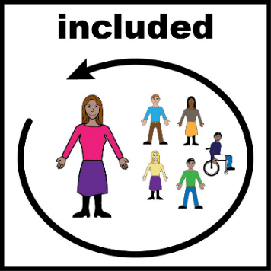

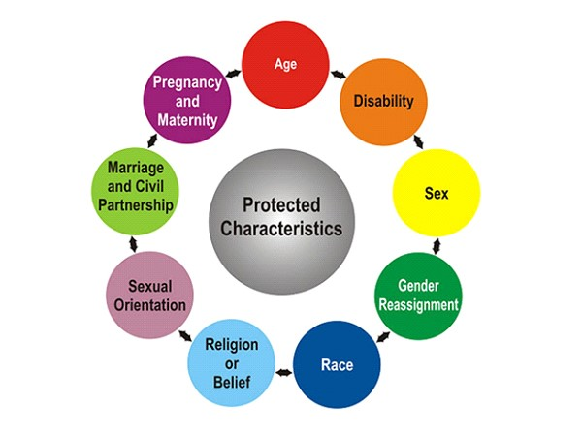

Mortuary Service - Royal Albert Edward infirmary
Wrightington, Wigan and Leigh Teaching Hospitals NHS Foundation Trust, provides a comprehensive mortuary service that includes the receipt and temporary storage of bodies for both the hospital and local community. Post-mortem examinations are undertaken on behalf of the HM Coroner for Greater Manchester West and the service accommodates visiting relatives.
The mortuary service is regulated by the Human Tissue Authority and ensures that deceased patients are properly cared for and that their families receive respectful and sensitive treatment. The service also includes the return of deceased persons' personal possessions to their relatives and the handling of deaths occurring in hospital settings.
The mortuary at Royal Abert Edward Infirmary is in an individual building situated to the rear and left of the hospital and has one very simple room (not a Chapel of Rest); this is used for both viewings and identifications - it provides private surroundings for immediate next of kin only who were unable to be present at the time of death.
Viewings are arranged by appointment with next of kin only, by contacting the Mortuary Service direct. Friends and distant relatives are encouraged to see their relative / friend to pay their last respects at the funeral Director’s Chapel of Rest.
Deceased patients are cared for by a small team of 5 members of staff working in the mortuary.
It is a small facility and during busy periods deceased patients may be moved to Leigh Infirmary Mortuary, where there is the same care provided by the team, until the chosen funeral director is able to transfer in to their care.

Mortuary Staff Statement
“We do our best; the patient must always come first. We are a small team, only 5 of us work here. Last winter there were 190 patients in the mortuary it was difficult. We provide the same care to the patients as the nurses do on the wards”

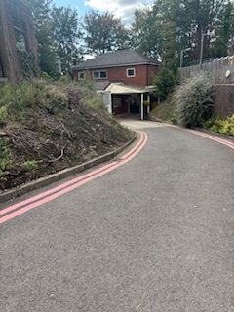
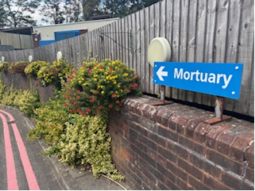

Evidence 1: Can all patients access to the service?

Protected Characteristic | Evidence on how each group can access this service
Sex  (assigned at birth)  Male / Female | Unisex single toilet facilities available for patient’s relatives.  Non-clinical, private viewing area and separate private waiting area.  Access to Bereavement Liaison Nurse.  Viewing times are arranged by appointment only – Private viewings.
Gender  Re-assignment  (Transgender / Non-Binary / Gender Fluid) | Unisex single toilet available for patient’s relatives.  Guidance available for staff on supporting trans and non-binary community.  Non-clinical, private viewing area and separate private waiting area.  Access to Bereavement Liaison Nurse.  Viewing times are arranged by appointment only – Private viewings.
Age  (18 years+) | The mortuary provides a comprehensive mortuary service for deceased patients of all ages (babies, children and adults).
Race or Ethnicity | Access to interpreter and translation services is available for patient’s parents/relatives/next of kin from different ethnicities who do not speak English as their first language.  WWL provides access to the following interpreter and translation services:  - Face to Face and telephone interpreters  - British Sign Language Interpreter (face to face)  - Information can be made available in other languages on request.  Relatives can use the Viewing Room for body washing rituals if required for cultural reasons.  An out-of-hours on-call service is available which facilitates the release of faith deaths if required.  Access to Hospital Chaplaincy Team and Bereavement Support Nurse. Access to Hospital Chapel.
Disability: | Access to disabled toilet facilities for patient’s relatives.  Access to British Sign Language Interpreters if required (pre-booked) for viewings.  E-mail can be used to communicate with hearing impaired relatives.  Information can be made available in audio, large print and braille on request  Guide dogs are allowed to accompany relatives.  There is ramped entrance to the mortuary (but the pathway to the mortuary is on a very steep hill, making it possibly difficult for families and wheelchair users. The mortuary is a small building and can be restrictive for wheelchair users) There is no parking available directly near the mortuary.  Bariatric fridge facilities are available at Leigh if required.  All staff have attended Oliver McGowen Training
Sexual Orientation | Staff ensure that deceased patients are properly cared for and that their families receive respectful and sensitive treatment.  Staff have an awareness of Equality, Diversity and Inclusion and are respectful of everyone.
Religion / Belief (please specify) | Religious needs of the deceased patient are taken into consideration and met. Religion / Faith recorded in notes and factored within deceased patient’s care plan.  The Mortuary Team are culturally sensitive to all religions and work in partnership with undertakers of different religious groups.  Relatives can use the Viewing Room for body washing rituals if required.  An out-of-hours on-call service is available which facilitates the release of faith deaths if required.  Access to Chaplaincy and Spiritual Care Team. Prayer Room available on site.  Access to interpreter and translation services.
Marriage & Civil Partnership | Civil Partnership now recognised within registration system of death.
Pregnancy & Maternity | Bereavement Specialist Nurse available  Bereavement Midwife available to support families through these difficult times.  Private viewing room available (moses baskets for babies)  Patient Information Leaflets available (Guidance and Support for Relatives of the Bereaved)  Breast Feeding Room and baby Changing facilities available on site for relatives

Evidence 2: Are all individual Patients health needs being met? (having needs met in a way that works for them)

Patient Care Plans
Staff ensure that deceased patients are properly cared for and that their families receive respectful and sensitive treatment.

Religious needs of the deceased patient are taken into consideration and met. Religion / Faith recorded in notes and factored within deceased patient’s care plan.

If a need/adjustment in relation to a patient’s protected characteristic is required, then this is considered
For Example:
- We are able to facilitate ritual washings if requested.

- We have a non-faith viewing room which is big enough to position the patient as required for any faith death i.e. facing mecca.

Equality Impact Assessment

An Equality Impact Assessment is undertaken on the Mortuary Service every 3 years. Last Assessment undertaken December 2024. We use this assessment to identify potential impacts, both positive and negative across all 9 protected characteristics, and look at how we could avoid disadvantage or further improve the delivery of our services.

To view a copy of our equality impact assessment please e-mail EDI@wwl.nhs.uk

Evidence 3: Are patients free from harm when they use the service? (feel safe / there are procedures in place to ensure safety)

Trust Risk Management Policy

It is Trust Policy that all serious incidents / complaints are investigated, and lessons learnt embedded within Trust practice.
All staff working in the Mortuary have a role in identifying risk and ensuring patients and relatives are protected from harm.

Patient Care Plans
Staff ensure that deceased patients are properly cared for and that their families receive respectful and sensitive treatment.

Lessons Learned from Incidents embedded within everyday activity

Parents are welcomed to the mortuary with their child if escorting. Staff need to be notified so that they can be prepared.

For parents who have experienced a child death in the Emergency Department, it has been agreed that parents are encouraged to say goodbyes in Accident and Emergency due to the length of time they are there. The mortuary staff can come and meet parents if the death happens in hours.

Evidence: Patients report positive experiences of the service

Patient / Relative feedback

The Trust collects and obtains feedback from patients through its PALS processes and patient surveys which are reported to the Trust Board of Directors

It is very rare for feedback to be given from relatives using the Mortuary Service due to the emotions families are going through at the time.
Relative Experience Surveys

Mortuary Staff do not routinely collect feedback from patient’s relatives about their experience. This is a particularly stressful and emotional time for them.
This is an area the department however would like to engage with / look at how feedback could be obtained in the future..

Stakeholders Scores Table (See Scoring Guide below)
Outcome | Score | Comments
Can all patients (who need to) access the service? Have equal access.

When patients use the service, are they free from harm? (feel safe / procedures in place to ensure safety)

Are individual patient’s health needs being met?
(having needs met in a way that works for them)

Do patients report positive experiences?

Scoring Guide

Underdeveloped | Developing
SCORE 0    People from all protected groups  Fare poorly compared to people  overall / No evidence | SCORE 1    People from some protected groups  Fare as well as people  overall
Achieving | Excelling
SCORE 2    People from most protected groups Fare as well as people  overall | SCORE 3    People from all protected  groups Fare as well as people  overall

