**Neonatal Unit, Royal Albert Edward Infirmary - Equality Engagement**

The Equality Delivery System (EDS) is a framework which was created by the Department of Health to help NHS Organisations to make improvements on equality, diversity and inclusion. To improve the services they provide for their local communities, consider health inequalities in their local area and provide better working environments free of discrimination.

**WWL want you, our service users and local community to have a say on our equality and inclusion work for our Neonatal Unit. We want to:**

**Show you what we currently provide and what we are working on**

**Ask you “are we getting it right for everyone / people from all protected characteristics?”**

**Tell us how well you think we are doing - Score us on the following questions**

**Help us decide what we need to do next**

**When patients use the service, do they feel safe?**

(free from harm)

D **Can all patients (who need to) access the service?**

**Are patients reporting positive experiences?** take

**Are individual patient’s health needs being met?**

(receiving good care)

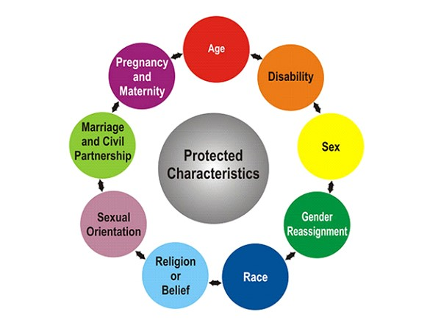

**Neonatal Unit – What we provide**

Neonatal care is the type of care a baby born premature or sick receives in a neonatal unit.

Units are a part of hospitals which provide care for babies soon after they are born. The word ‘neonatal’ means newborn, or the first 28 days of life.

At Royal Albert Edward Infirmary, we have a 14 bedded Neonatal Unit. Here we provide Intensive, High Dependency and Special Care for babies born above 27 weeks gestation.

We are a dynamic and forward-thinking team, consisting of Consultants, Doctors, Specialist Neonatal Nurses, HCA’s. We also have a Community Outreach Team and a Transitional Care Unit.

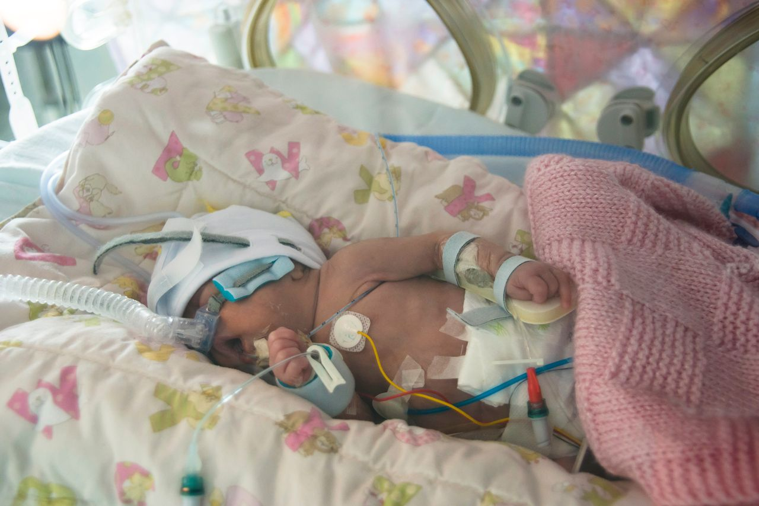

[This Photo](https://innovations.bmj.com/content/early/2017/01/04/bmjinnov-2016-000145) by Unknown Author is licensed under [CC BY](https://creativecommons.org/licenses/by/3.0/)

On our Neonatal Unit we support families and our emphasis is on Family Integrated Care, this enables parents to take the lead in their babies care with support from the nursing staff on the unit.

We were awarded the North West Neonatal ODN Ficare Accreditation Award in 2023. As part of this we have four “never evers” that we promise to parents/guardians.

* We will never move a baby into a cot for the first time.
* We will never dress a baby for the first time.
* We will never weigh a baby.
* We will never bath a baby.

We are part of the Greater Manchester Neonatal Network and have access to specialist support they provide.

|  |
| --- |
| **Evidence 1: Can all patients (who need to) access to the service?** |
| **Personalised Individual Care Plans**  **WWL recognise every baby and every family is different. All patients have a personalised individual care plan.** They are involved in the infants’ care and parents are supported. This helps to identify what matters to them and ensure that their care reflects this. Family situation, health and well-being and preferences are discussed.  **If a need / adjustment in relation to a family’s protected characteristic is required, then this is considered at the beginning of the infant’s journey with us.**  **For example:**   * If a parent has a disability, we ensure reasonable adjustments are put in place so they can fully access the service. * If a parent has a learning disability, we would offer support. We would allow them to have an additional named visitor. We would take time to explain things to the parent to ensure they understand, sometimes using a doll to demonstrate, also using de-medicalised language to ensure understanding. * We support families who are LGBTQIA+ and ensure the parents have the right support in place. For example, our care plans ask for parent/guardian name as opposed to Mum and Dad. We have supported several same sex couples who have had a surrogate deliver their babies or have undertaken fertility treatment. * We have supported many young mothers. Age is therefore considered, to ensure understanding and if any reasonable adjustments can be put into place. * We ask about a families’ ethnicity, we can give families information leaflets in different languages and offer interpreter services. We are also currently updating our communication digital platform for parents which will have an option for language to be translated. * Our parents will have recently given birth (been pregnant) we provide our families with a packed lunch and a hot evening meal should they desire. We also have a family room where parents can make a hot drink or prepare their own food. This room also has reclining chairs for the parents to relax in. |
| **Equality Impact Assessment**  **An Equality Impact Assessment is undertaken on the Neonatal Unit every 3 years. Last Assessment undertaken September 2024.** We use this assessment to identify potential impacts, both positive and negative across all 9 protected characteristics, and look at how we could avoid disadvantage or further improve the delivery of our services. |
| **Access to** **Interpreter and Translation Services**  We have full access to interpreter and translation services for patient’s parents/relatives/carers from different **ethnicities** who do not speak English as their first language.  **WWL provides access to the following interpreter and translation services:**   * Face to Face and telephone interpreters * British Sign Language Interpreter (face to face and video remote on demand) * Patient information can be made available in large print, audio, easy read and braille on request**.** |
| **Access to multi-faith chaplaincy and spiritual care services**   * **Prayer facilities** on all hospital sites. * **Cultural beliefs / traditions** documented in notes and adhered to (within care plan)   **Patient’s Special Dietary Requirements catered for**   * **Halal / Vegetarian / Vegan / Special Diets** |
| **Neonatal Outreach Service**  For those babies that meet the criteria, further support is provided following discharge by the Neonatal Outreach Team. The experienced Neonatal Nurses get to know the family on the unit and follow up at home with support on feeding, home oxygen and monitoring weight. |
| **Safeguarding**  We recognise that some families who have spent an extended period of time in hospital may need further support prior to discharge. For the babies who have been an inpatient for 90 days or more, we have a statutory duty to refer to social services for any support they can offer. |
| **Assistance Dogs Policy and Procedure**  Implemented following complaint regarding access in maternity services in 2015. Policy sets out roles and responsibilities of staff to support access for patients/visitors with assistance dogs. Procedure identifies the process for allowing access to assistance dogs within the Trust. |
| **Examples of Reasonable Adjustments Made**  We recently cared for a same sex couple who had become parents via a surrogate. The couple were supported on the unit. They were supported on the unit just the same as any new parent. They had access to the family room prior to discharge allowing them to provide total care for the infant.  We recently cared for a parent who identified as non-binary. We ensured that their preferred pronouns were documented and made known to all staff. We also ensured that the parent’s preferred name was visible above the cot space.  We regularly care for parents whose first language is not English. We ensure that they receive the same updates from the medical team through the correct language interpreter where they have the time to ask any questions and gain understanding of their baby’s condition. |
| **Evidence 2: Are all individual Patients health needs being met?** (having needs met in a way that works for them) |
| **Personalised Individual Care Plans**  Any babies admitted to the Neonatal Unit have an individual plan of care that is reviewed daily by the medical team in collaboration with the neonatal nurses and the parents as part of FiCare. The plan of care is tailored to that baby and we move forward following recommended guidelines whilst also considering the needs of the individual baby.  Babies that are identified to have further health needs are discussed with the appropriate speciality in a tertiary centre where we incorporate their recommendations into our plan of care. Our doctors perform some procedures at the cot side such as cranial ultrasounds and echocardiograms. Should a baby need an x-ray, they are performed on the unit and we often arrange same day ultrasounds to the x-ray department if needed.  We recognise that some treatment/procedures cannot be facilitated within our own trust and babies are therefore transferred out so they can receive that treatment. For example, if they require a SALT assessment. Working with the transport team, this is often arranged so the baby can return to our unit later the same day. |
| **Palliative Care**  We work alongside Derian House Children’s Hospice to put a personalised care plan in place for children with life limiting or terminal conditions. We provide support to the families ensuring that their wishes and beliefs (cultural) are upheld and respected throughout the process. |
| **Parental Support**  We offer the same support for all our families. Recognising the stress/anxiety that comes with having a baby admitted to the neonatal unit, we ensure that families are aware of the support available to them. SPOONS is a charity that offers support to the whole family including siblings. The support staff from SPOONS have themselves had children on a neonatal unit so can offer support to these families having experienced a lot of the same emotions on the neonatal journey. |
| **Dads Matter**  Staffing on the unit is predominantly female and sometimes dads may find it easier to speak to another male about how they are feeling after their child has been born. The Dad’s Matter support group is heavily signposted on the unit. The group is run by volunteers who have also had children on the neonatal unit, they provide 1-1 and group support for dads. We have arranged for a member of the group to visit the unit every other Wednesday to provide support to any dads who may need it. |
| **Reasonable Adjustments**  Single/young mums are allowed another named visitor to provide support should they need it.  The hospital chaplain visits the unit to other religious/spiritual support to our families. In some circumstances infants may be baptised or given a blessing at the cot side. |

|  |
| --- |
| **Evidence 3: Are patients free from harm when they use the service?** (feel safe / there are procedures in place to ensure safety) |
| **Trust Risk Management Policy**  **All serious incidents / complaints are investigated, and lessons learnt embedded within Trust practice.**  All staff working within Neonatal Services at WWL have a role in identifying risk and ensuring children and adults are protected from harm. Neonatal staff are likely to have significant contact with families who may require support and interventions in relation to safeguarding. All neonatal staff need to be aware of national and local procedures and their responsibility in relation to these. |
| **Think Family Safeguarding Team**  Based WWL NHSFT covering all hospital sites and community services, providing maternity and neonatal care. The WWL NHSFT Think Family Safeguarding Team has a statutory requirement to ensure the Trust are compliant with National Safeguarding and oversee the effectiveness of our Safeguarding Service provision. The WWL Think Family Safeguarding Team has A Name Midwife, Named Nurse for Adults, Named Nurse for Children and Named Nurse for Children in Care. |
| **National MBRRACE Reports and Action Plans**  Each year the MBRRACE Report ”Saving Lives, Improving Mothers’ Care” is published as part of the Maternal Newborn and Infant Clinical Outcome Review Programme. The report looks at data from the UK and Ireland confidential enquiries into how many women had died during child birth. And the 12 months after. The report provides statistics on these deaths as well as summaries on the circumstances around them; and makes suggestions on preventions and lessons to be learnt. WWL reviews this report and embeds recommendations / changes to guidelines within local maternity improvement action plans. WWL reports on neonatal deaths and still births. |
| **Complex Medical Conditions Individual Management Plans**  All babies with complex medical conditions have a clear treatment plan with the relevant members of the multi-disciplinary team. The medical team on the unit liaise closely with specialists to deliver the correct care to each individual baby. Parents are updated and involved in any decision making around their baby, care is tailored to them through the principles of Fi-Care (Family Integrated Care). |
| **Example of recent incident and lessons learned**  We have recently cared for a baby who was transferred to us for palliative care. The family were supported through making an end of life care plan which was specific to them. They were able to make memories with their baby and decided they would take them home to die surrounded by family. When the baby deteriorated, the family felt that they wanted her to die around people who knew her and had cared for her. Even though the baby had been discharged, the family were supported by our staff and the baby had a dignified death in our family room with parents present. Afterwards the family were grateful at having had the support and their wishes being upheld. |

|  |
| --- |
| **Evidence: Patients report positive experiences of the service** |
| **A screenshot of a graph  Description automatically generatedA screenshot of a web page  Description automatically generatedA close-up of a question  Description automatically generatedNeonatal Patient Experience Survey 2024** |
| **CQC National Maternity Survey 2021**  The 2021 Maternity Survey involved 122 NHS trusts in England. All NHS trusts providing maternity services that had at least 300 live births were eligible to take part in the survey. Women aged 16 years or over who had a live birth between 1 and 28 February 2021 (and January if a trust did not have a minimum of 300 eligible births in February) were invited to take part in the survey. Fieldwork took place between April and August 2021. Responses were received from more than 23,000 women, an adjusted response of 52%  **297**  Eligible at the end of survey  **37%**  Completed survey  (109)  **300**  Invited to complete the survey  98% Treated with respect and dignity (during labour & birth)  97% Had confidence and trust in staff (during labour & birth)  96% Involved enough in decisions about their care (during labour & birth)  The results show that despite the constraints of the Covid pandemic, our results are predominantly in line with other trusts, with 1 result worse, and 1 result somewhat worse, than most trusts. The somewhat worse result is now actioned with the implementation of our Perinatal Mental Health Midwife and should see improvement in the next report. The worse result continues to be worked on with the planning of implementation of continuity teams.  **Demographics:**  **97%** White  **2%** Asian / Asian British  **1%** Black / African / Caribbean / Black British  **0%** Mixed / Multiple Ethnic Groups  **0%** Other Ethnic Group  **7%** 16-25year olds  **28%** 26-30 year olds  **45%** 31-35 year olds  **19%** 36+ year olds  **31%**  respondents said they had a long-term condition.  **WWL National Maternity Survey 2021 Action Plan**  An Action Plan based on the CQC Maternity survey report for WWL is produced and monitored. |
| **Maternity Friends and Family Results – (Maternity Labour Ward)**  The Friends and Family Test (FFT) is an important feedback tool that supports the fundamental principle that people who use NHS services, should have the opportunity to provide feedback on their experience.  The FFT asks people about their experience of services they have used and offers a range of responses.  **Feedback Scores received from 225 patients during Oct 2023 to Oct 2024**  **Positive:** 98% **Neutral:** 1% **Negative: 1**% |

**EQUALITY IMPACT ASSESSMENT**

|  |  |  |  |  |
| --- | --- | --- | --- | --- |
| **Protected Characteristic** | **Positive Impact**  High  Low  None | **Negative Impact**  High  Low  None | **Reason/Comments for Positive Impact**  **(Why it could benefit any / all of the protected characteristics)** | **Reason/Comments for Negative Impact**  **(Why it could disadvantage any / all of the protected characteristics)** |
| Men | High | None | Toilet and shower facilities available for parents / carers.  Refreshments and rest room available for parents / carers.  Parents / carers involved (asked what matters to them).  Dedicated Family room provided.  Parents / guardians allowed to stay all day. |  |
| Women | High | None |  |
| Transgender / Gender Re-assignment / Non-binary | High | None | Parents / Carers involved (asked what matters to them).  Family setting, health and well-being and preferences discussed.  Care plans ask for parent/guardian name as opposed to mum and dad.  Preferred pronouns documented and staff made aware.  Parent/Guardian name visible above cot space. |  |
| Age  (18 years+) | High | None | Age of parent / guardian is considered in Individual Care Plan to ensure understanding and if any reasonable adjustments are required. |  |
| Race or Ethnicity | High | None | Access to interpreter and translation services.  Access to Multi-faith Chaplaincy and Spiritual Care Services.  Special dietary requirements catered for.  Cultural beliefs / traditions documented in notes and adhered to (within care plan) | . |
| Hearing Impairment | High | Low | Access to BSL Interpreters (Face to face & video remote).  Provision of additional support available / reasonable adjustments accommodated.  Access to transparent face masks. | No hearing loop on ward. Can be accessed from other departments if required. |
| **Protected Characteristic** | **Positive Impact**  High  Low  None | **Negative Impact**  High  Low  None | **Reason/Comments for Positive Impact**  **(Why it could benefit any / all of the protected characteristics)** | **Reason/Comments for Negative Impact**  **(Why it could disadvantage any / all of the protected characteristics)** |
| Visual Impairment | High | None | Information / correspondence can be provided in braille, large print, audio on request.  Provision of additional support available / reasonable adjustments accommodated. Carer support available |  |
| Physical Disability | High | None | Accessible toilet and bathroom accommodation for parents / carers.  Additional support available / reasonable adjustments accommodated. Carer support available |  |
| Learning Disability | High | None | Carer support available.  Additional named visitor accommodated.  Additional support available / reasonable adjustments  accommodated. Time taken explaining (doll can be used to demonstrate / non-medical simple language used). |  |
| Mental Health Need | High | None | Carer support available / reasonable adjustments accommodated.  Parents / Carers involved (asked what matters to them). Needs factored within individual care plan. |  |
| Gay/Lesbian/  Bisexual | High | None | Parents / Carers involved (asked what matters to them). Family setting, health and well-being and preferences discussed.  Care plans ask for parent/guardian name as opposed to mum and dad.  Same sex couples supported (including those who have had a surrogate deliver or undertaken fertility treatment). |  |
| Religion / Belief | High | None | Cultural beliefs / traditions documented in notes and adhered to (within care plan).  Prayer Room available on site.  Access to Chaplaincy and Spiritual Care Servicers.  Access to interpreter and translation services.  Special dietary requirements catered for. |  |
| **Protected Characteristic** | **Positive Impact**  High  Low  None | **Negative Impact**  High  Low  None | **Reason/Comments for Positive Impact**  **(Why it could benefit any / all of the protected characteristics)** | **Reason/Comments for Negative Impact**  **(Why it could disadvantage any / all of the protected characteristics)** |
| Marriage & Civil Partnership | Low | None | Same sex couples supported (including those who have had a surrogate deliver or undertaken fertility treatment). |  |
| Pregnancy & Maternity | High | None | Family setting, health and well-being discussed and included in care plan. Parents / carers involved (asked what matters to them).  Refreshments and rest room available for parents / carers.  Breast feeding facilities (separate breast milk fridge)  Parents / families who have recently given birth (been pregnant) are offered lunch and evening meals. A family room where parents can make a hot drink or prepare their own food is available. This room also has reclining chairs for the parents to relax in. |  |
| Carer Status | High | None | Carer support available.  Access to Wigan Council’s Carer Support Team. |  |

**Stakeholders Scores Table (See Scoring Guide below)**

|  |  |  |
| --- | --- | --- |
| **Outcome** | **Score** | **Comments** |
| **Can all patients (who need to) access the service?** Have equal access. |  |  |
| **When patients use the service, are they free from harm?** (feel safe / procedures in place to ensure safety) |  |  |
| **Are individual patient’s health needs being met?**  (having needs met in a way that works for them) |  |  |
| **Do patients report positive experiences?** |  |  |

**Scoring Guide**

|  |  |
| --- | --- |
| **Underdeveloped** | **Developing** |
| **SCORE 0 – Little or No Evidence**  **Sad face outline outline**  **People from all protected groups**  **Fare poorly compared to people**  **overall / No evidence** | **SCORE 1 – Some Evidence 50%**  **Neutral face outline with solid fill**  **People from some protected groups**  **Fare as well as people**  **overall** |
| **Achieving** | **Excelling** |
| **SCORE 2 – Adequate Evidence 75%**  **Smiling face outline with solid fill**  **People from most protected groups Fare as well as people**  **overall** | **SCORE 3 – Extensive Evidence 98%**  **Winking face outline with solid fill**  **People from all protected**  **groups Fare as well as people**  **overall** |