Wigan Borough – Community Health and Wealth Building Anchor Partnership

Terms of Reference



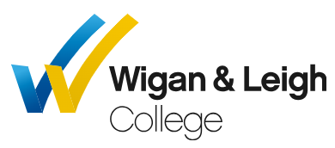

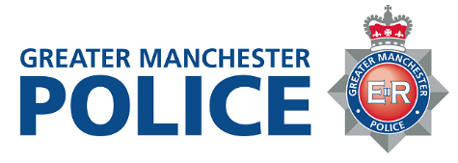
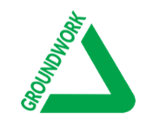


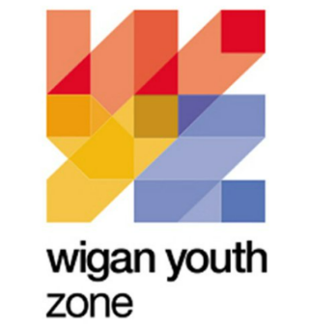


Wigan Borough Community Health & Wealth Anchor Partnership - Terms of Reference
Community Health and Wealth Building Anchor Partnership:
Our partnership was established in 2020 with key partners coming together with a strong commitment and shared vison to tackle inequalities in our borough.
Through community health and wealth building we aim to harness the combined power of local communities, local anchor institutions and businesses to build an economy that works for us all.
Working together we have made considerable progress linked to procurement, recruitment, employment and skills and we now want to build on this success and reach further, deeper and wider to make the biggest impact for the people that live and work here.
Our New Era for Wigan Borough – Progress with Unity - defines our two core missions as a council: to create fair opportunities for all our children, families, residents and businesses, and make all our towns and neighbourhoods flourish for those who live and work in them. Community wealth building is an integral component of our new era recognising that community wealth is community health. It is a key priority for the Council and we are taking a progressive and creative approach to social value and how we make the most positive impact for the people that live and work here through our commissioning and contracting, really connected to our communities, as a key tool to help build community health and wealth in the borough.
We recognise that there is huge potential for us as an anchor institution to influence the social and economic determinants of health in the borough. We are committed to working individually and collectively as partners on different projects to boost economic, social, health and education prospects for local communities.
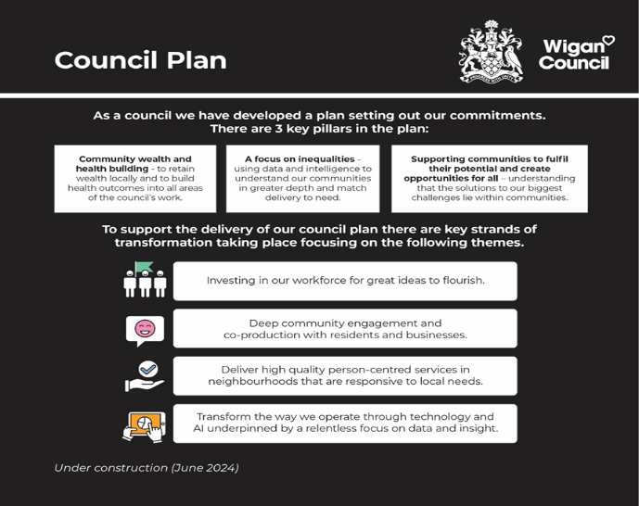
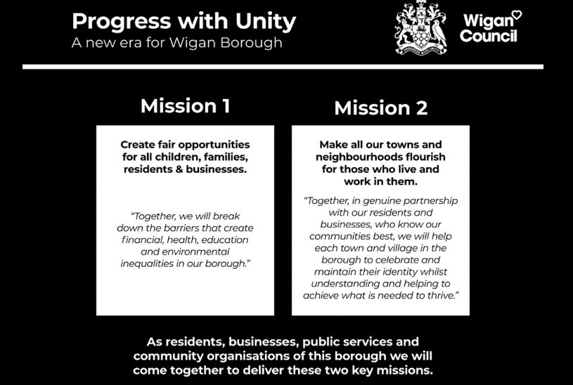

Membership:
The Partnership consists of:

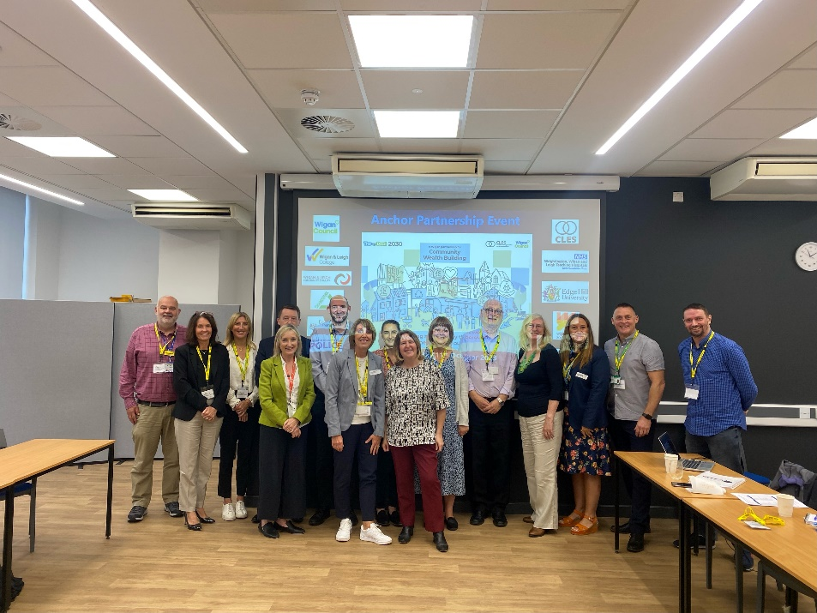
Wigan Council
Wigan & Leigh College
WWL
Edge Hill University
Wigan Youth Zone
Groundwork
DWP
Greater Manchester Police
Greater Manchester Fire & Rescue Service
Wigan & Leigh Community Charity
CLES

Anchor institutions:
Anchor institutions are large organisations rooted in place with significant spending power, workforces and financial and physical assets. They are at the heart of CWB because their economic power means they can have big impacts on the economy.

Our partners have all committed to exerting their sizable influence through their commissioning and purchasing of goods and services, through their workforce and employment capacity, and by creative use of their facilities and land assets. Positive use of these levers can affect change within the wider economic, social and environmental determinants of health.
Purpose of the Board
Our Anchor Partnership agreed to adopt a set of principles and ways of working to help scale up our collective approach to building community health and wealth across the borough:
- Recruiting from all our communities;
- Procuring from good, local businesses;
- Ownership of the economy by local people;
- Developing new growth sectors;
- Skills training to match a new economy;
- Shaping markets to benefit local people;

The partnership agreed to work towards some key priorities which were to:
- Commit with ambition as an anchor partnership to take a community wealth building approach across the whole public and third sector in Wigan borough and engage proactively with the private sector.
- Embed community wealth building into our procurement policies, recruitment processes and way we manage our assets and drive forward our ambitions on green jobs, housing, and working with businesses of all kinds.
- Bring together community, citizens and businesses to make this happen and create the conditions for community wealth building to thrive and change to happen.

Plans & Priorities:
We have developed a shared agreement which contains our priorities for 2024. This year, we want to elevate our commitment to Community Health and Wealth Building and use it as a key enabler to address the health inequalities across the borough. We want to use our sizeable assets to support local communities, we want to be a good partner to businesses and the VCFSE sector and build trust and relationships with residents. During the next 12 months, we agree to focus on the following priorities through our subgroups and leads.

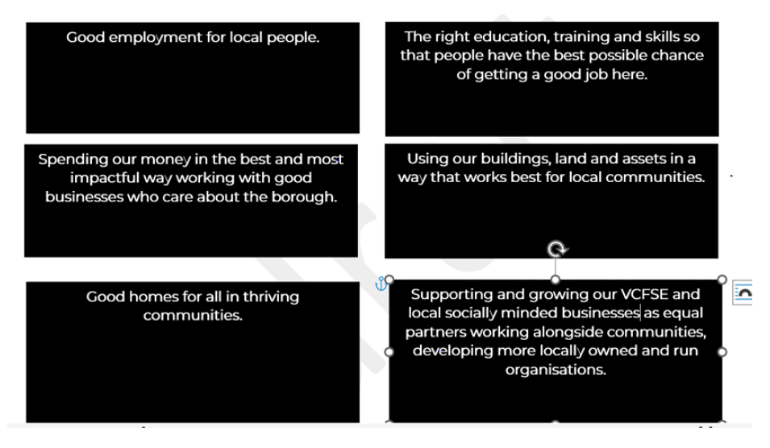

A series of sub-groups to be established to deliver against these aims, generating a shared set of deliverables that can have the most impact in terms of tackling our Progress with Unity Missions. These sub-groups will have membership from across the Anchor Partnership and report back into the wider Partnership meetings.
Leads for sub-groups:
The right education, training and skills:
Good Employment for local people:
Spending public money in the best and most impactful way: Chris Clark
Using our Buildings and Assets in a way that works best for local communities: Josh Balmer
Supporting our VCFSE sector:
Good homes for all in thriving communities:

As members of the Wigan Borough Anchor Partnership, we agree to the principles of Community Health and Wealth Building and will work together to deliver the conditions for our residents, communities and businesses to flourish and fulfil their maximum potential through Progress with Unity.

