
POLICY NAME: | Code of Conduct
POLICY ID NUMBER: | TW10-099
VERSION NUMBER: | 6
APPROVING COMMITTEE: | Partnership Committee
DATE THIS VERSION APPROVED: | November 2019
RATIFYING COMMITTEE: | PARC
DATE THIS VERSION RATIFIED: | December 2019
AUTHOR(S) (JOB TITLE) | Deputy Director of HR and Staff Side Chair
DIVISION/DIRECTORATE: | Workforce/Corporate
LINKS TO ANY OTHER POLICIES/PROCEDURES: | Disciplinary Policy  Grievance Policy  Fraud, Corruption and Bribery & Response Plan  Standard Financial Instructions (SFI’s)  Conflict of Interest Policy (inc. Gifts and Hospitality)
CONSULTED WITH: | Policy Development Group

Date(s) previous version(s) approved:  (If known) | Version: 5 | Date: October 2015
DATE OF NEXT REVIEW: | December 2022, extended to April 2023.  Extended to July 2023. Now extended October 2023
Manager responsible for review:  N.B. This should be the Author’s line manager | Director of Workforce



CONTENTS |  | PAGE NO.
1 | INTRODUCTION | 2
2 | POLICY STATEMENT | 2
3 | KEY PRINCIPLES | 3
4 | RESPONSIBILITIES: | 3
5 | BEHAVIOURS | 4
6 | STANDARDS | 5
7 | DECLARATIONS | 5
8 | FRAUD, CORRUPTION AND BRIBERY | 6
9 | HUMAN RIGHTS ACT | 6
10 | EQUALITY & DIVERSITY | 6
11 | MONITORING AND REVIEW | 6
12 | ACCESSIBILITY STATEMENT | 6

APPENDICES
1 | Declaration Form | 7
2 | Equality Impact Assessment Form | 9
3 | Monitoring & Review template | 10

AT ALL TIMES, STAFF MUST TREAT PATIENTS WITH RESPECT
AND UPHOLD THEIR RIGHT TO PRIVACY AND DIGNITY.

- INTRODUCTION
The Committee on Standards in Public Life created ‘The Seven Principles of Public Life’, also known as the ‘Nolan Principles’. The seven principles are: Selflessness; Integrity; Objectivity; Accountability; Openness; Honesty; and, Leadership. The Code of Conduct is to remind staff of these principles and to ensure they work and behave in a manner which reflects them and embraces the WWL Wheel, values and the Trust’s Behaviour Framework to assist staff in maintaining strict ethical standards in the conduct of NHS business.

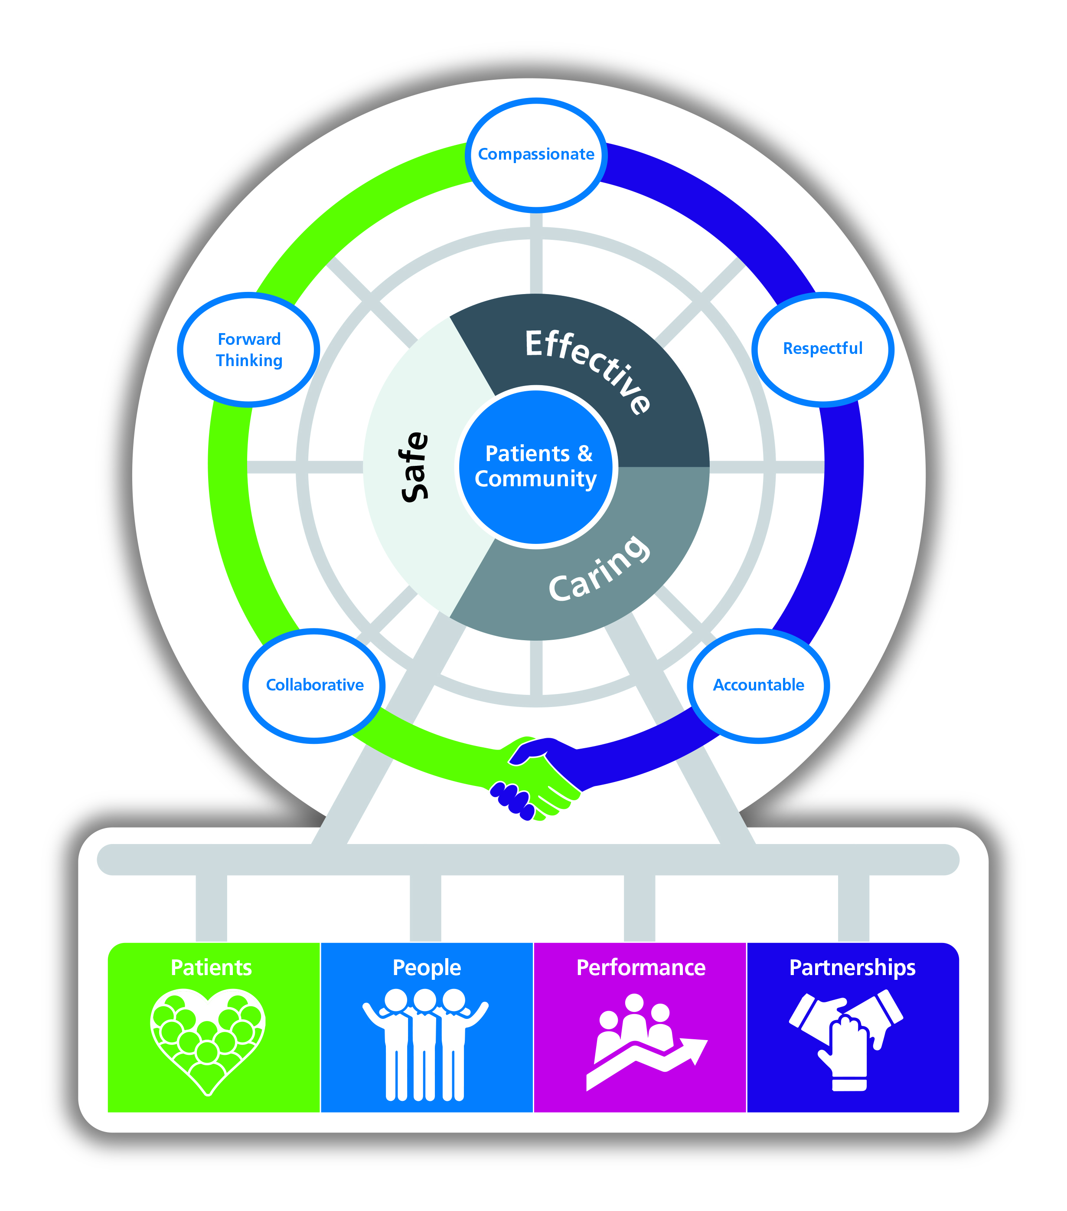
2. POLICY STATEMENT
2.1 This policy explains the standards of conduct and behaviour expected of all staff and volunteers.

2.2 This Policy applies to all staff employed by the Trust on a permanent or temporary basis. Issues relating to professional misconduct of Medical and Dental staff should be managed under the Trust’s Maintaining High Professional Standards Policy. The term “staff” is a collective term that includes part time or temporary staff, locums, agency staff, contractors, interim staff, volunteers or any other form of employment, either directly or otherwise with Wrightington, Wigan and Leigh NHS Foundation Trust.

2.3 Conduct expected of all staff incorporates those defined as ‘rules’ within the Trust’s Disciplinary Policy. If any employee has any doubt about the meaning of a rule they must ask for clarification during their induction training or from their line manager.

2.4 If staff are uncertain about the correctness or propriety of any proposed business transactions, or in relation to hospitality, declaration of interests and commercial sponsorship then they must seek guidance from their Line Manager or Human Resources Department in the first instance.

2.5 If an employee takes any action which is not consistent with the rules referred to within the Disciplinary Policy or other relevant Trust protocols such as the Standing Financial Instructions; Fraud, Corruption and Bribery & Response Policy; Conflicts of Interest Policy or the standards of behaviour reflected by the Code of Conduct the Trust will consider appropriate action in accordance with the relevant policy or procedure.

2.6 In addition to this Code of Conduct, employees are also required to abide by the Codes of Conduct and/or Code of Practice of any professional body of which they are a member.

3. KEY PRINCIPLES
  - The Trust expects all employees to behave appropriately and professionally. Everyone has the right to be treated fairly, with equity, dignity and respect in the application of this policy.

  - The Code of Conduct should be referred to in conjunction with the Disciplinary Policy and Trust’s 'Behaviour Framework'. (NB. This can be located within the Route Planner page on the Trust’s Intranet System)

  - Where a matter of fraud or corruption is alleged/suspected, such instances may be investigated as outlined within the Disciplinary Policy or by the Trust’s Local Counter Fraud Specialist in line with the Fraud, Corruption and Bribery & Response Policy and may lead to disciplinary action and/or prosecution and civil recovery proceedings where appropriate. No list of rules can be exhaustive, and the rules contained within the Disciplinary Policy and this Code of Conduct are the minimum standards expected of employees.

4. RESPONSIBILITIES
4.1 Trust Board

4.1.1 The responsibility for the provision of a Code of Conduct rests initially with the Trust Board.
4.1.2 The Trust Board will ensure, through the line management structure, that this policy is applied fairly and equitably and that all relevant persons are aware of the standards of conduct required.

4.2 Chief Executive
The Chief Executive has overall responsibility for the strategic direction and operational management of this policy.

4.3 Responsibility of Managers

4.3.1 Line managers are responsible for ensuring that this policy is applied fairly and consistently within their own area.
4.3.2 Line managers should also ensure that all relevant persons are aware of and understand the Code of Conduct.
4.3.3 In implementing the Code of Conduct, managers must ensure that all staff are treated fairly and within the provisions and spirit of the Trust’s Inclusion and Diversity Strategy.

4.4 Responsibility of Human Resources

4.4.1 The Human Resources Department will oversee the introduction, operation and monitoring of this code and will report to the Trust Board on a regular basis to ensure the fair and consistent application of the policy throughout the Trust.
4.4.2 The Human Resources Department will answer queries in relation to this policy at a local level, as appropriate, and ensure the Code of Conduct is applied fairly and consistently throughout the Trust.
4.4.3 The Human Resources Department will ensure the provision of training, guidance and support to line managers on the operation of this Code.

4.5 Responsibility of Staff

4.5.1 All staff are responsible for adhering to the Code of Conduct. Employees should understand that this policy is also incorporated into their contract of employment.
4.5.2 All staff are responsible for asking their manager for clarification if they do not understand any rule within this or any another Trust policy.
4.5.3 All staff should behave in a way that is reflective of the ‘Nolan Principles’ and embraces the Trust’s Values and Behaviour Framework.
4.5.4 As representatives of the Trust, all employees are reminded of the need to liaise appropriately with third parties, including participating with internal and external investigations.

5 BEHAVIOURS
5.1 This Code of Conduct and the associated additional documents referred to in it, is not intended to list exhaustively the behaviours expected of staff. Staff should use their own common sense and not expect the Trust to make explicit, every possible example of unacceptable conduct.

5.2 Fundamental to the relationship between the Trust and its staff is the assumption that staff will perform their duties to the best of their ability, at all times acting in the interests of patients, service users, and the Trust.

5.3 Staff should maintain their professional competence and, where applicable, registration to practice.

5.4 Staff should always report any concerns they have about standards of care.

5.5 Staff should treat each other, and everyone they come into contact with, with dignity and respect.

5.6 Staff should ensure they are familiar with all policies and procedures relevant to their role and adhere to them.

5.7 Staff should inform their line manager, or if necessary another manager as appropriate, if they believe there are any circumstances which might affect their ability to do their job, such as ill health, substance addiction or dependency, external investigations, criminal matters, or similar.

5.8 Staff should comply with the relevant standards set by their regulatory or professional bodies (for example the GMC's Good Medical Practice, and for nurses and midwives, the NMC's Code of Professional Conduct). A breach of such standards may lead to action by NHS bodies independent of any action taken by the regulatory or professional body concerned. It will be investigated fairly and appropriate steps taken to prevent a recurrence and address any wider causes.
6 STANDARDS
6.1 As a staff member you should:-

6.1.1 Ensure you are familiar with the guidelines within the Trust’s Code of Conduct, and consult your line manager if you are not sure;
6.1.2 Make sure you are not in a position where your private interests and NHS duties may conflict;
6.1.3 Declare to the Trust any relevant interests or relationships;
6.1.4 Declare any additional employment, external to the Trust with your line manager (special guidance applies to doctors);
6.1.5 Report any conduct or behaviour which may constitute criminal offences against the Trust’s assets or resources, such as fraud, bribery or corruption, and report concerns or suspicions appropriately;
6.1.6 Respect confidential information obtained in the course of your work at all times.
6.2 As a staff member you should not;

6.2.1 Accept any gifts, inducements or inappropriate hospitality which might be interpreted as seeking to exert undue influence to obtain preferential consideration. Staff should not accept significant personal gifts or hospitality from contractors and outside suppliers;

6.2.2 Abuse your past or present official position to obtain preferential rates for private deals;

6.2.3 Misuse, make available or benefit from official ‘commercial in confidence’ information.

7 DECLARATIONS – including Declaration of Interest, Commercial Sponsorship, Gifts and Hospitality and Secondary Employment
7.1 It is a mandatory requirement for all staff of Band 8 and above to complete and submit a Declaration of Interests form in accordance with the Trust’s Standing Financial Instructions to confirm the accuracy of information they have previously provided and provide details of any changes to that information (these are available on Trust intranet/Company Secretary; via the Trust’s Financial Controller, see appendix 1; or via the Finance page of the intranet. A ‘nil’ response should be provided if no declaration is made.

7.2 Declarations should be made to line managers unless otherwise advised within relevant Trust policies or protocols. An appropriate record should be kept for any future reference. Further information is within the Trust’s Disciplinary Policy and advice required can be sought from the HR Department or Company Secretary in this regard.

7.3 Commercial sponsorship for attendance at a course, conference or social event. This should include any event where you have been invited to speak in return for a free delegate place, if payment has been received in addition to a free delegate place and conference expenses, this would be recorded as additional employment (if in doubt, please contact the Company Secretary). Staff must be aware of the possibility of bias generated through sponsorship, where this might impinge on professional judgement and impartiality.

7.4 Gifts and Hospitality. Any acceptance of a gift needs to be justified and should not be accepted as an inducement, staff may individually or on behalf of a team accept token gifts (up to the value of £50). These low value gifts do not have to be registered. All other gifts and hospitality offered at a value of £50 or above need to be declared by completing the Declarations of Gifts and Hospitality section of the declarations form (see appendix 1), If a formal offer of a gift/hospitality has been offered, but declined this should also be declared - Declarations@wwl.nhs.uk
Further advice can also be obtained from the Company Secretary.

7.5 Secondary Employment/Employment outside NHS contract - Staff may engage in paid employment outside their NHS contract, unless this affects their ability to fulfil their contractual duties. Staff must discuss any additional employment with their line manager. Failure to declare such employment, especially employment which may conflict with, or be detrimental to, their Trust work could incur formal action in line with the Trust’s Disciplinary Policy and/or the Trust Counter Fraud, Corruption and Bribery Policy.

8 FRAUD, CORRUPTION AND BRIBERY
In accordance with the Trust’s Fraud, Corruption and Bribery and Response Policy, any suspicious activity, within the scope of this policy, will be referred to and subsequently investigated by the Trust’s Local Counter Fraud Specialist (LCFS). The results of any such investigation could lead to internal disciplinary and/or civil/criminal prosecution proceedings being instigated against the appropriate person/persons involved. Further details can be located within the Disciplinary Policy, both policies can be located on the Trust intranet.

9 HUMAN RIGHTS ACT
Implications of the Human Rights Act have been taken into account in the formulation of this policy and they have, where appropriate, been fully reflected in its wording.

10 EQUALITY AND DIVERSITY
The Policy has been assessed against the Equality Impact Assessment Form from the Trust’s Equality Impact Assessment Guidance and, as far as we are aware, there is no impact on any Equality Target Group.

- MONITORING AND REVIEW:
Policy to be reviewed every 3 years.

12 ACCESSIBILITY STATEMENT:
This document can be made available in a range of alternative formats e.g. large print, Braille and audio cd.

For more details, please contact the HR Department on 01942 77 (3766) or email equalityanddiversity@wwl.nhs.uk

Appendix 1
(This form is available via intranet - Finance Directorate’s page)


Declaration of Interest. Commercial Sponsorship, Gifts and Hospitality and Secondary Employment Form
Name: □ ……….…………………………………………………………………… (Please select from global address)
Assignment Number□……………………………………………………………………………………………………………………
Band Number□……………………………………………….Division□ ………………………………………………………………..
Department: □………………..……………………………………………………………………...........................................
Unit/Team: □…………………………………………………………..……………………………………………………………………..
Signature(If available) □………..………………………………….……………………………..……..……………………………
Date: □ …………………………………..…………………….
Line Manager Email address (Please select from global address list) □………………………………………………………………………………………………………………………………………………………….
Type of declaration
Please note this is a mandatory requirement for all staff (including contractors, temporary and agency staff). If ‘NIL’ return please declare this.
Please tick one only – If you have more than one declaration to make please repeat the survey.
□ Declaration of interest – please complete the declaration of any business interest of yourself, your partner or spouse, which are, or may be relevant to, the work of the Trust or your work within the organisation.
- I wish to make a declaration of interest
- I submit a nil return

Please give the details of any relevant business interests which you wish to declare:-
Name of Organisation: ….…………………….…………….……………………………….........………………………………….
Relationship: …………………………………………..………………………………………………………………………………………
When did business interest begin? ………………………………………..........................................................
How is this relevant to the work of the organisation? ……………………………………………..……..………………………………………………………………………………………………….
□ Commercial sponsorship for attendance at a course, conference or social event
This should include any event where you have been invited to speak in return for a free delegate place, if payment has been received in addition to a free delegate place and conference expenses this would be recorded a additional employment (if in doubt, please contact the Trust Secretary). Staff must be aware of the possibility of bias generated through sponsorship, where this might impinge on professional judgement and impartiality
- Event title ……………………………………………………………………….
- Event date……………………………….□type of event………………………………………………..
□ Sponsor………………………………… □Location………………………………………………………
□ Value of sponsorship…………………………………………………………………………………….

□ Gifts and Hospitality
Any acceptance of a gift needs to be justified and should not be accepted as an inducement, staff may individually or on behalf of a team accept token gifts (up to the value of £50). These low value gifts do not have to be registered. All other gifts and hospitality offered at a value of £50 or above need to be declared by completing this Declarations of Gifts and Hospitality form. If you are still unsure – Declare It! Further advice can also be obtained from the Trust Secretary.

□Details of gifts or hospitality (inc name of organisation or individual who offered or supplied the gift/hospitality ……………………………………………………………………………………………………………
□Value (where known)…………………………………………………………………………………………………………………….
□Date offered………………………………………………………………………………………………………………………………….
□By whom and why (please give as much details as possible…………………………………………………………..
Gift accepted or declined
□Yes, I confirm acceptance of the gift
□No, offer declined
□Comments
…………………………………………………………………………………………………………………………………………………………
□ Secondary Employment/Employment outside NHS contract
Staff may engage in paid employment outside their NHS contract, unless this affects their ability to fulfil their contractual duties. Staff must discuss any additional employment with their line manager. Failure to declare such employment, especially employment which may conflict with, or be detrimental to, their Trust work could incur formal action in line with the Trust’s Disciplinary Policy and/or the Trust Counter Fraud and Corruption Policy.
□ Details of secondary employment (including self-employment)
□Employer………………………………………………………………………………
□nature of business………………………………………………………………..
□Time commitment …………………………………………………………………
In completing this form, I can confirm that I have the approval with my line manager for this additional employment
□Line manager name …………………………………………………………………………………
□Date approval confirmed………………………………………………………………………….
If at any time your declaration changes and you are affected by one or more of the above you must complete this form at that time, and in any instance that you feel appropriate
Return to – financial.services@wwl.nhs.uk
For Gifts and Hospitality return to - Declarations@wwl.nhs.uk
Appendix 2

Equality Impact Assessment Form

STAGE 1 - INITIAL ASSESSMENT

For each of the protected characteristics listed answer the questions below using  Y to indicate Yes and  N to indicate No | Sex  (male / female / transgender) | Age  (18 years+) | Race / Ethnicity | Disability  (hearing / visual / physical /  learning disability /  mental health) | Religion / Belief | Sexual Orientation  (Gay/Lesbian/  Bisexual) | Gender Re-Assignment | Marriage / Civil Partnership | Pregnancy & Maternity | Carers | Other Group | List Negative / Positive Impacts Below
Does the policy have the potential to affect individuals or communities differently in a negative way? | N | N | N | N | N | N | N | N | N | N | N
Is there potential for the policy to promote equality of opportunity for all / promote good relations with different groups – Have a positive impact on individuals and communities. | Y | Y | Y | Y | Y | Y | Y | Y | Y | Y | Y
In relation to each protected characteristic, are there any areas where you are unsure about the impact and more information is needed? | N | N | N | N | N | N | N | N | N | N | N | If Yes: Please state how you are going to gather this information.

Job Title | Deputy Director of HR |  |  | Date | 26.03.19

IF ‘YES an NEGATIVE IMPACT’ IS IDENTIFIED - A Full Equality Impact Assessment STAGE 2 Form must be completed. This can be accessed via http://intranet/Departments/Equality_Diversity/Equality_Impact_Assessment_Guidance.asp
Please note: As a member of Trust staff carrying out a review of an existing or proposal for a new service, policy or function you are required to complete an Equality Impact Assessment. By stating that you have NOT identified a negative impact, you are agreeing that the organisation has NOT discriminated against any of the protected characteristics. Please ensure that you have the evidence to support this decision as the Trust will be liable for any breaches in Equality Legislation.
Appendix 3

POLICY MONITORING AND REVIEW ARRANGEMENTS

NAME OF POLICY/SOP or CLINICAL GUIDELINE:

Para | Audit / Monitoring requirement | Method of Audit / Monitoring | Responsible person | Frequency of Audit | Monitoring committee | Type of  Evidence | Location  where evidence is held
11 | Review after 3 years | Via HR/Staff side partnership | Senior HRBP | 2 year | PDG/Partnership | N/A | N/A

10

