BUMP, BABY AND YOU
INFANT FEEDING RESOURCES

English Language Videos - Global Health Media Project
BREASTFEEDING AND HAND EXPRESSING VIDEOS

COLOSTRUM HARVESTING LEAFLET
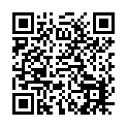

64d3405786e503.08128184.pdf (wwl.nhs.uk)

UNICEF BABY FRIENDLY INITIATIVE INFANT FEEDING AND RELATIONSHIP BUILDING INFORMATION LEAFLETS AND VIDEOS
Baby Friendly Resources - Baby Friendly Initiative (unicef.org.uk)

SAFE SLEEP
The Lullaby Trust - Safer sleep for babies, Support for families

VITAMIN D RECCOMENDATIONS AND HEALTHY START VOUCHERS
Getting vitamins – Get help to buy food and milk (Healthy Start)

