
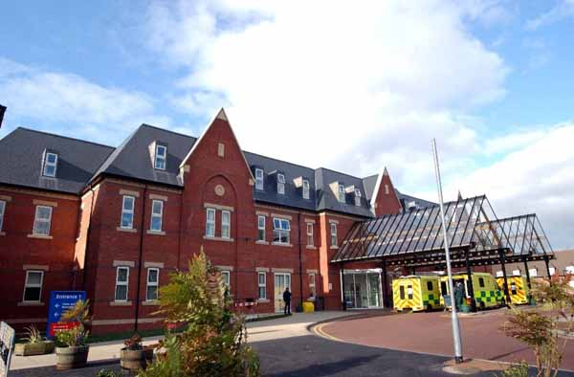

PATIENT INFORMATION PASSPORT

For patients with learning or physical disabilities having planned and emergency admissions.

HOSPITAL LIAISON TEAM – 0300 7071345 (answer machine)

My allergies are:-
CONTENTS

ABOUT ME:- My Personal Details page 3

My Medical Information page 4 – 6

My Likes and Dislikes, Sleep and Risk page 7

COMMUNICATION: - My Communication Hearing and Sight page 8

EATING AND DRINKING: - My Needs page 9

MOBILITY: - How I Mobilise page 10

PERSONAL CARE: - What Help do I need page 11

ADDITIONAL INFORMATION; - page 13

CONTACT LIST

My Personal Details
I like to be called: -

My age is: -

My NHS No is:-

My name is: -

My date of birth is: -

My address is: -

Post code: -

Telephone number: -
My next of kin is: -

They are available for consultation: -
My care package is:

I live with: - do I live with family, do I live independently, do I have my own home with carers

I live in a: - house – bungalow – flat – residential home – nursing home - other (please state)


My religion is: -

My religious requests are: -

My Medical Information

My Doctor (GP) is: -

Address: -

Postcode: -

Telephone number: -

Do I access my Annual Health Check offered by my GP?

Yes No Information on Annual Health checks given - YES/NO

https://www.nhs.uk/conditions/learning-disabilities/annual-health-checks/

https://www.youtube.com/watch?v=_C8R_bJdLSQ

How do I take my medication-
do I self-administer, do my carers give me my medication, do I have a drink with it, is my medication in liquid form? Is there an agreement in place regarding covert medication?

Correct at time of writing please also refer to repeat prescription sheets.


A Brief Medical History /Current Medical Condition
including any past procedures, do I have any metal work in my body? Have I had a General Anaesthetic in the past if so did I recover well? Is there a family history of diabetes etc…

How do I Tell you that I am in Pain/ feeling unwell?
Would I tell you verbally, would I suffer in silence, do I use sign, pictures, what pain relief am I prescribed, am I accepting of pain relief when it is offered? Is there a change to my behaviours, do I have a high pain threshold?

What reasonable adjustments do I need to have made?
i.e. a quiet place to wait, a first or last appointment? Shorter waiting time.

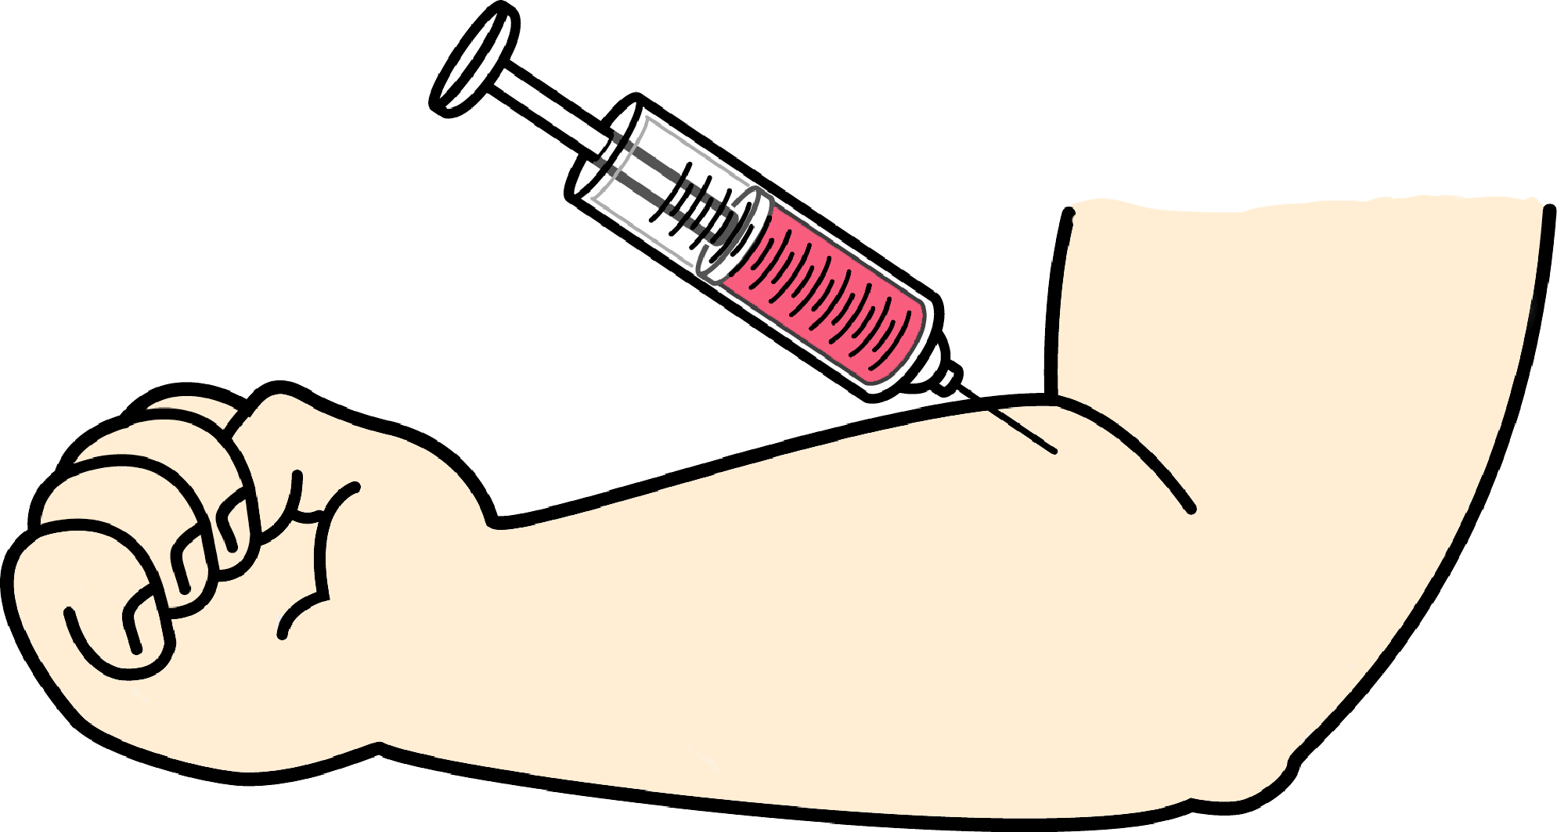

How to take my blood –

what support do I need, am I brave with needles or scared? Do I want an explanation of what is happening or is it better to just get on once I am at the appointment? You can phone head of an appointment to find out when the quietest time to attend is.

How Best to Support Me

How to give me injections –

what support do I need, am I brave with needles or scared? Do I want an explanation of what is happening or is it better to just get on once I am at the appointment?

How to take my temperature –

is this something I am use to having done, do I get ear infection or sore ears?

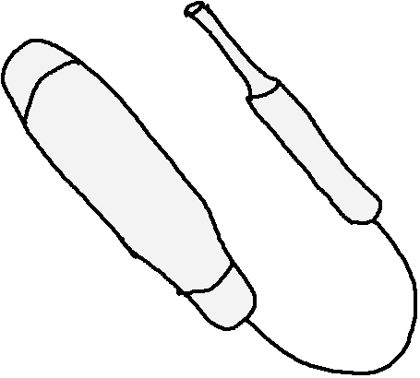

How to give me intravenous (IV) fluids –

would I pull cannulas and lines out, do I need a bandage going around the cannula, does the cannula need to be sited somewhere where I can’t reach it? Will I need constant supervision?

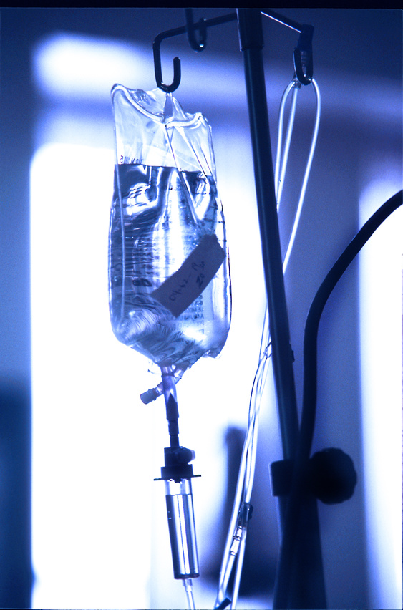

How to take my blood pressure –
do I need some reassurance, would it be better to take a reading from my ankle? Do I need step by step instructions, would I prefer my blood pressure checked manually or electronically?

How to give me an x-ray or scan –
can I follow instruction, would I be able to keep still, would the use of sedation need to be discussed? Do I need help to hold position?


Thinks I don’t like, what anxieties do I have:-

Things I like, what is important to me:-
What routines or structure do I need, is there anything that can ease my anxieties?

My Likes and Dislikes

Are there any issues with my sleep pattern –
do I sleep well, do I have night time sedation, what time do I go to bed/get up? What support do need if I get up during the night, do I have a sleep hygiene routine?

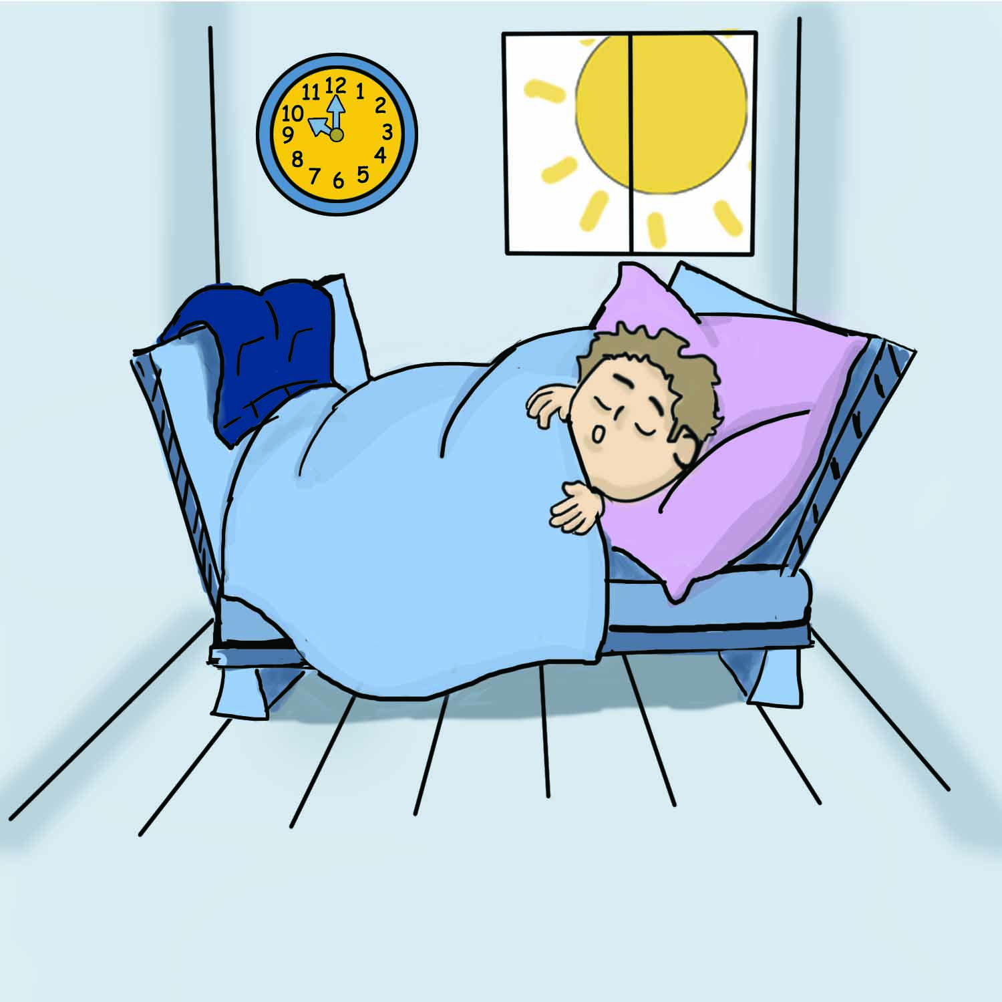
What is my understanding of risk –
Would I wander away from the ward, take someone else’s medication, am I able to summon help if needed, what is my understanding of stranger danger, do I understand road safety.

What risk do I pose to others –
Do I need constant support?

How do I communicate?
Do I speak, do I use sign, PEC’s, do I use communication aides such as I pads or translators, what is my first language, what is my capacity to understand?

How do you communicate with me?

COMMUNICATION

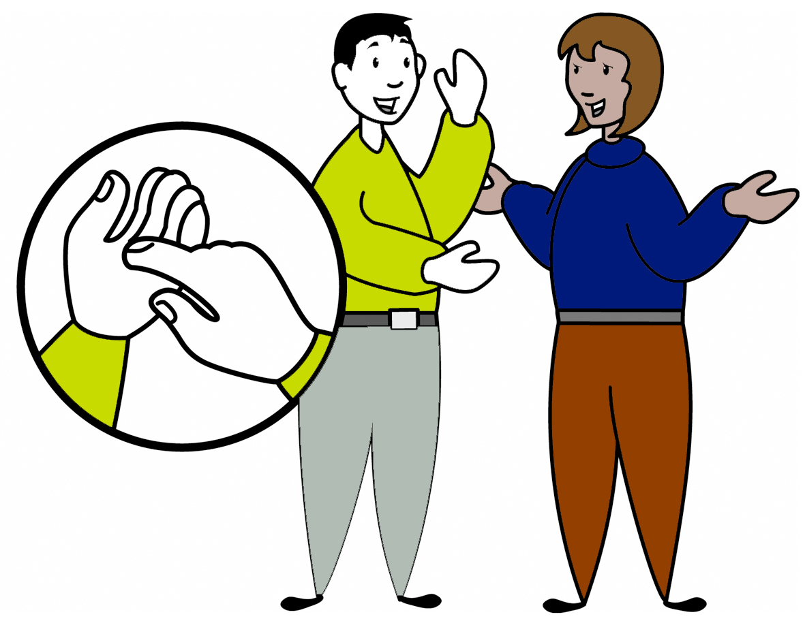

What is my hearing like-
do I have good hearing, do I use hearing aids, do I get wax build up, do I get recurring infections?

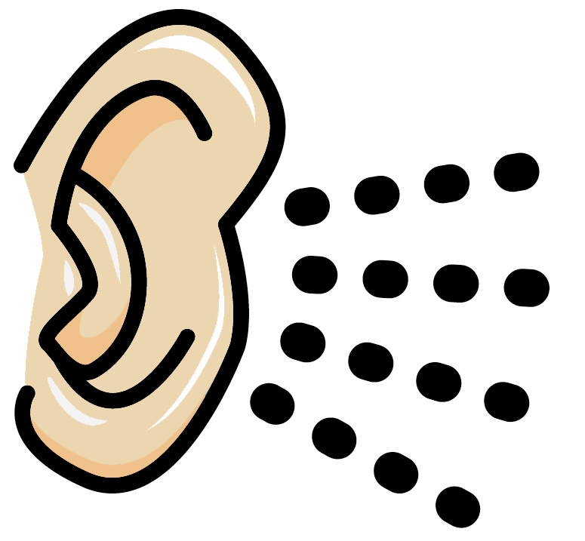

What is my eyesight like –
do I have good eyesight, do I wear glasses/contact lenses, am I sight impaired, am I colour blind, are there any issues with my sight i.e. cataracts etc…? Do I attend regular Optician appointments?

Do I have a special diet –
are there foods that I need to avoid, am I on a low fat diet, do I take supplements, do I need to watch my cholesterol, am I vegetarian? Are there any Speech and Language recommendations?

EATING AND DRINKING



What help do I need to eat my meals –
does my food need to be cut up, can I use a knife and fork, do I need full support to eat my meals?

Am I nil by mouth –
if yes what is my current feeding regime.

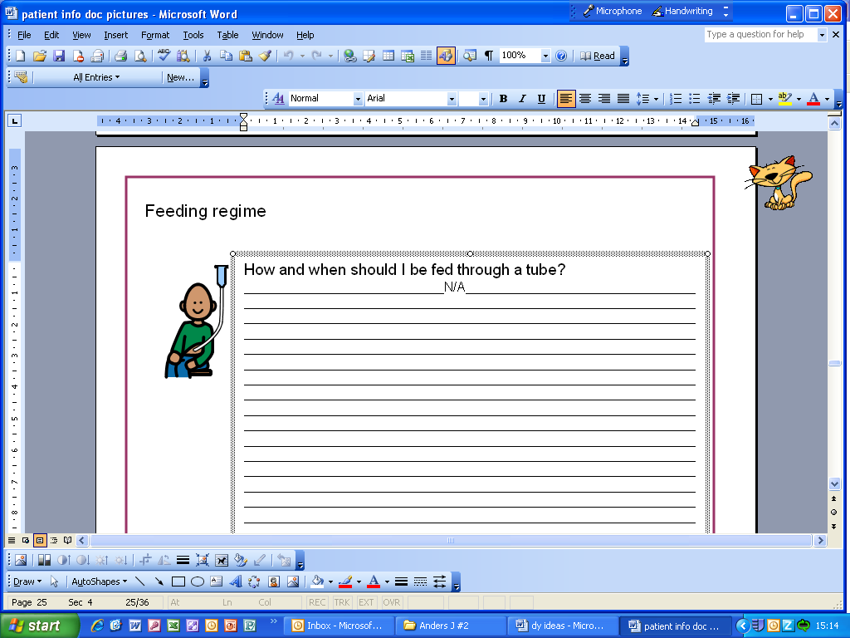
How do I take my fluids -
do I need supervision? Do my drinks need cooling/thickening? What type of drinks do I like? Do I use a regular cup, feeder cup or do I like to drink using a straw?

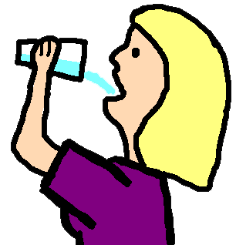

Am I able to mobilise independently-
If yes can I manage stairs, am I at risk of trips or falls, do I use a zimmer frame etc… do I need extra help to keep me safe, do I use specific foot wear?

MOBILITY

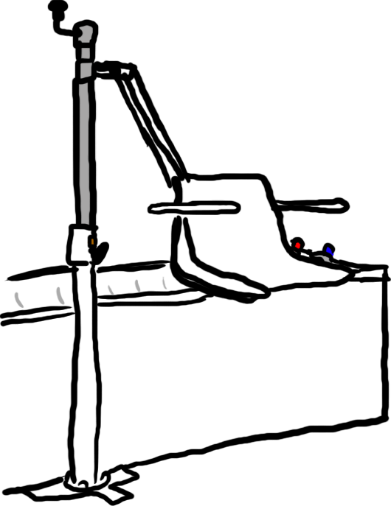
What equipment do I use at home to assist in my moving and handling –
Do I use a hoist, do I use a standing aides, can I weigh bear for transfers? Do I use a bath chair, grab rails etc…

What medical equipment do I use?
Do I have a suction machine, syringes, yankers (please include size and make).

What support do I need to have a bath/shower -
Do I need full support to wash, do I have sensitive skin, am I ok having water on my face, is it safe for me to be left alone in the bathroom? Do I need support to get in and out of the bath, when do I have my hair washed? What are my sensory needs, do I have a bath time routine?

PERSONAL CARE

What support do I need to wash -
Do I need prompt or reminders to wash my hands prior to a meal or following a visit to the bathroom?
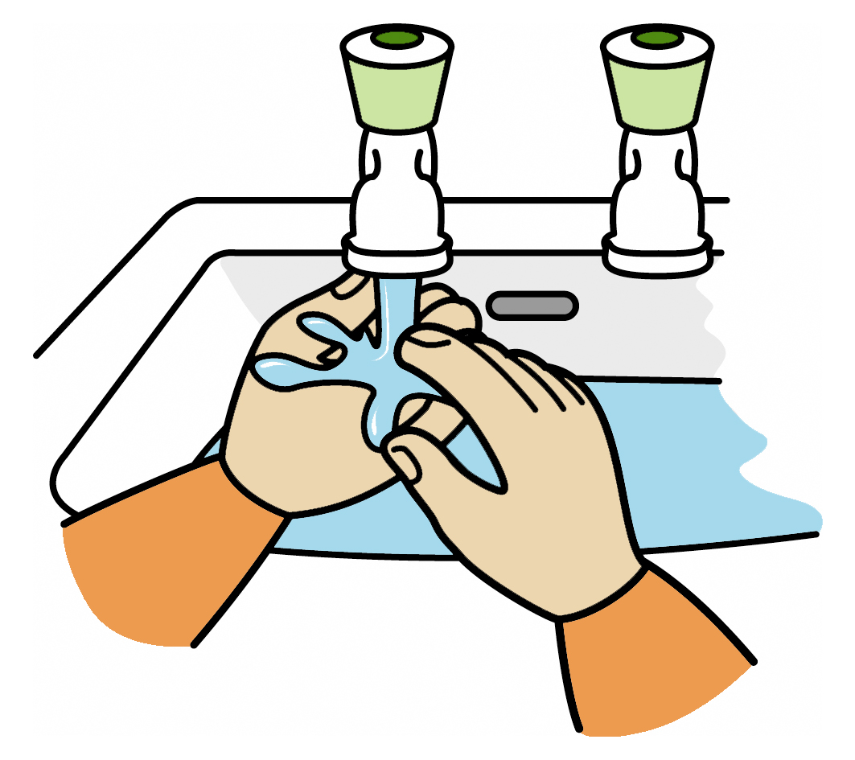
What support do I need to brush my teeth -
Can I brush my own teeth, do I need some support, do I access a Dentist, am I nil by mouth, do I use an electric or manual toothbrush, what kind of tooth paste do I like?



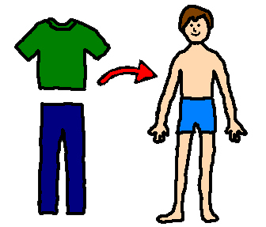
What help do I need to dress myself -
Can I choose clothing appropriate for the weather, can I manage zips, buttons and laces, do I need full support to dress/undress, are there any specific clothes that I must wear to feel happy, do I wear compression clothing?
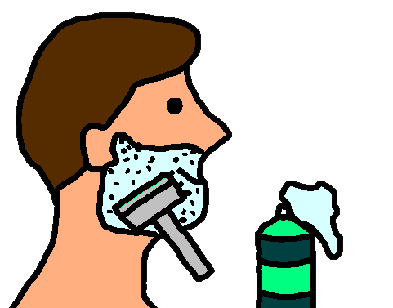
What help do I need to shave –
what type of shaver do I use, do I need to shave every day, do I use foam or soap, do I have sensitive skin.

What help do I need to keep my nails tidy -
Do I see Podiatry, do I have my nails cut or filed? Are there any issues with me having my nails cut; are there any issues with my feet?
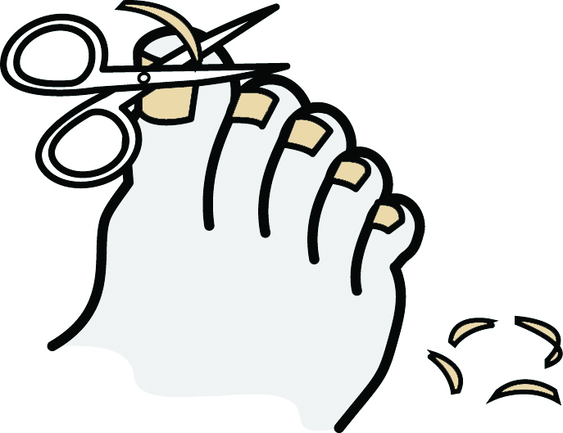

Menstruation –
what help do I need, are my periods regular, do I need pain relief? Do I need help to maintain my personal hygiene, do I have mood swings, am I on any medication i.e. the pill etc…


How do I show that I need to use the toilet –
do I need help to maintain my personal hygiene, do I use pads etc… do I go independently, do I have a history of water infections or constipation, do I have a bowel management plan?

ADDITIONAL INFORMATION

Please include epilepsy information, information around specific conditions i.e. crohns, behavioural management plans etc…

This document was created by Wrightington, Wigan and Leigh NHS Foundation Trust Learning Disability Team, Hospital Liaison Team, and the Accessible Communication Team.

This document acknowledges the use of symbols provided by Anthony Hobson

