**Me, my family and pets**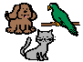

Age: 21

Live with: Mum, Dad, brother,and sister.

Robbie the dog

Slipper the cat

David the hedgehog.

I like watching films and Youtube. I love looking at photos! I LOVE animals

**Things that are important to me**

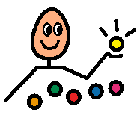

* Animals
* Doing what I want
* Music, especially Britpop
* Dogs
* Hedgehogs
* Running and walking
* Sweetcorn and crisps (not together)

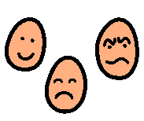 **My behaviours**

* I am easily distracted
* I go very quiet when I am unwell
* I mutter to myself when I’m annoyed
* Help me by reminding me of my now/next board or
* Offer me a sensory break

I need

* Visual timetable to plan my day
* Now and Next board

**How I communicate with you**

* Speech
* Natural body language
* Point to symbols
* Talker with talking App.
* Join 2 words

Please keep Talker with me all the time and put new symbols on as they come up.

I communicate best when:

* I am relaxed
* My sensory needs are met
* I have time to get over my shyness

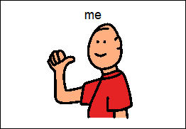

NAME

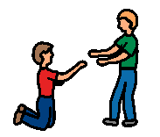**Things I need help with**

* My weighted blanket helps me sit still and listen
* Keep my ear defenders with me. I need them in a noisy environment. I hate loud or sudden noises.
* I need my stander 3 times/week
* Don’t tell me off if I bite my nails.

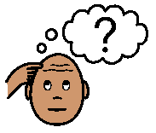**How I understand**

Please use:

* Single words and short phrases
* Familiar words
* Routines
* Sign and gesture

I need my visual timetable, used throughout the day.