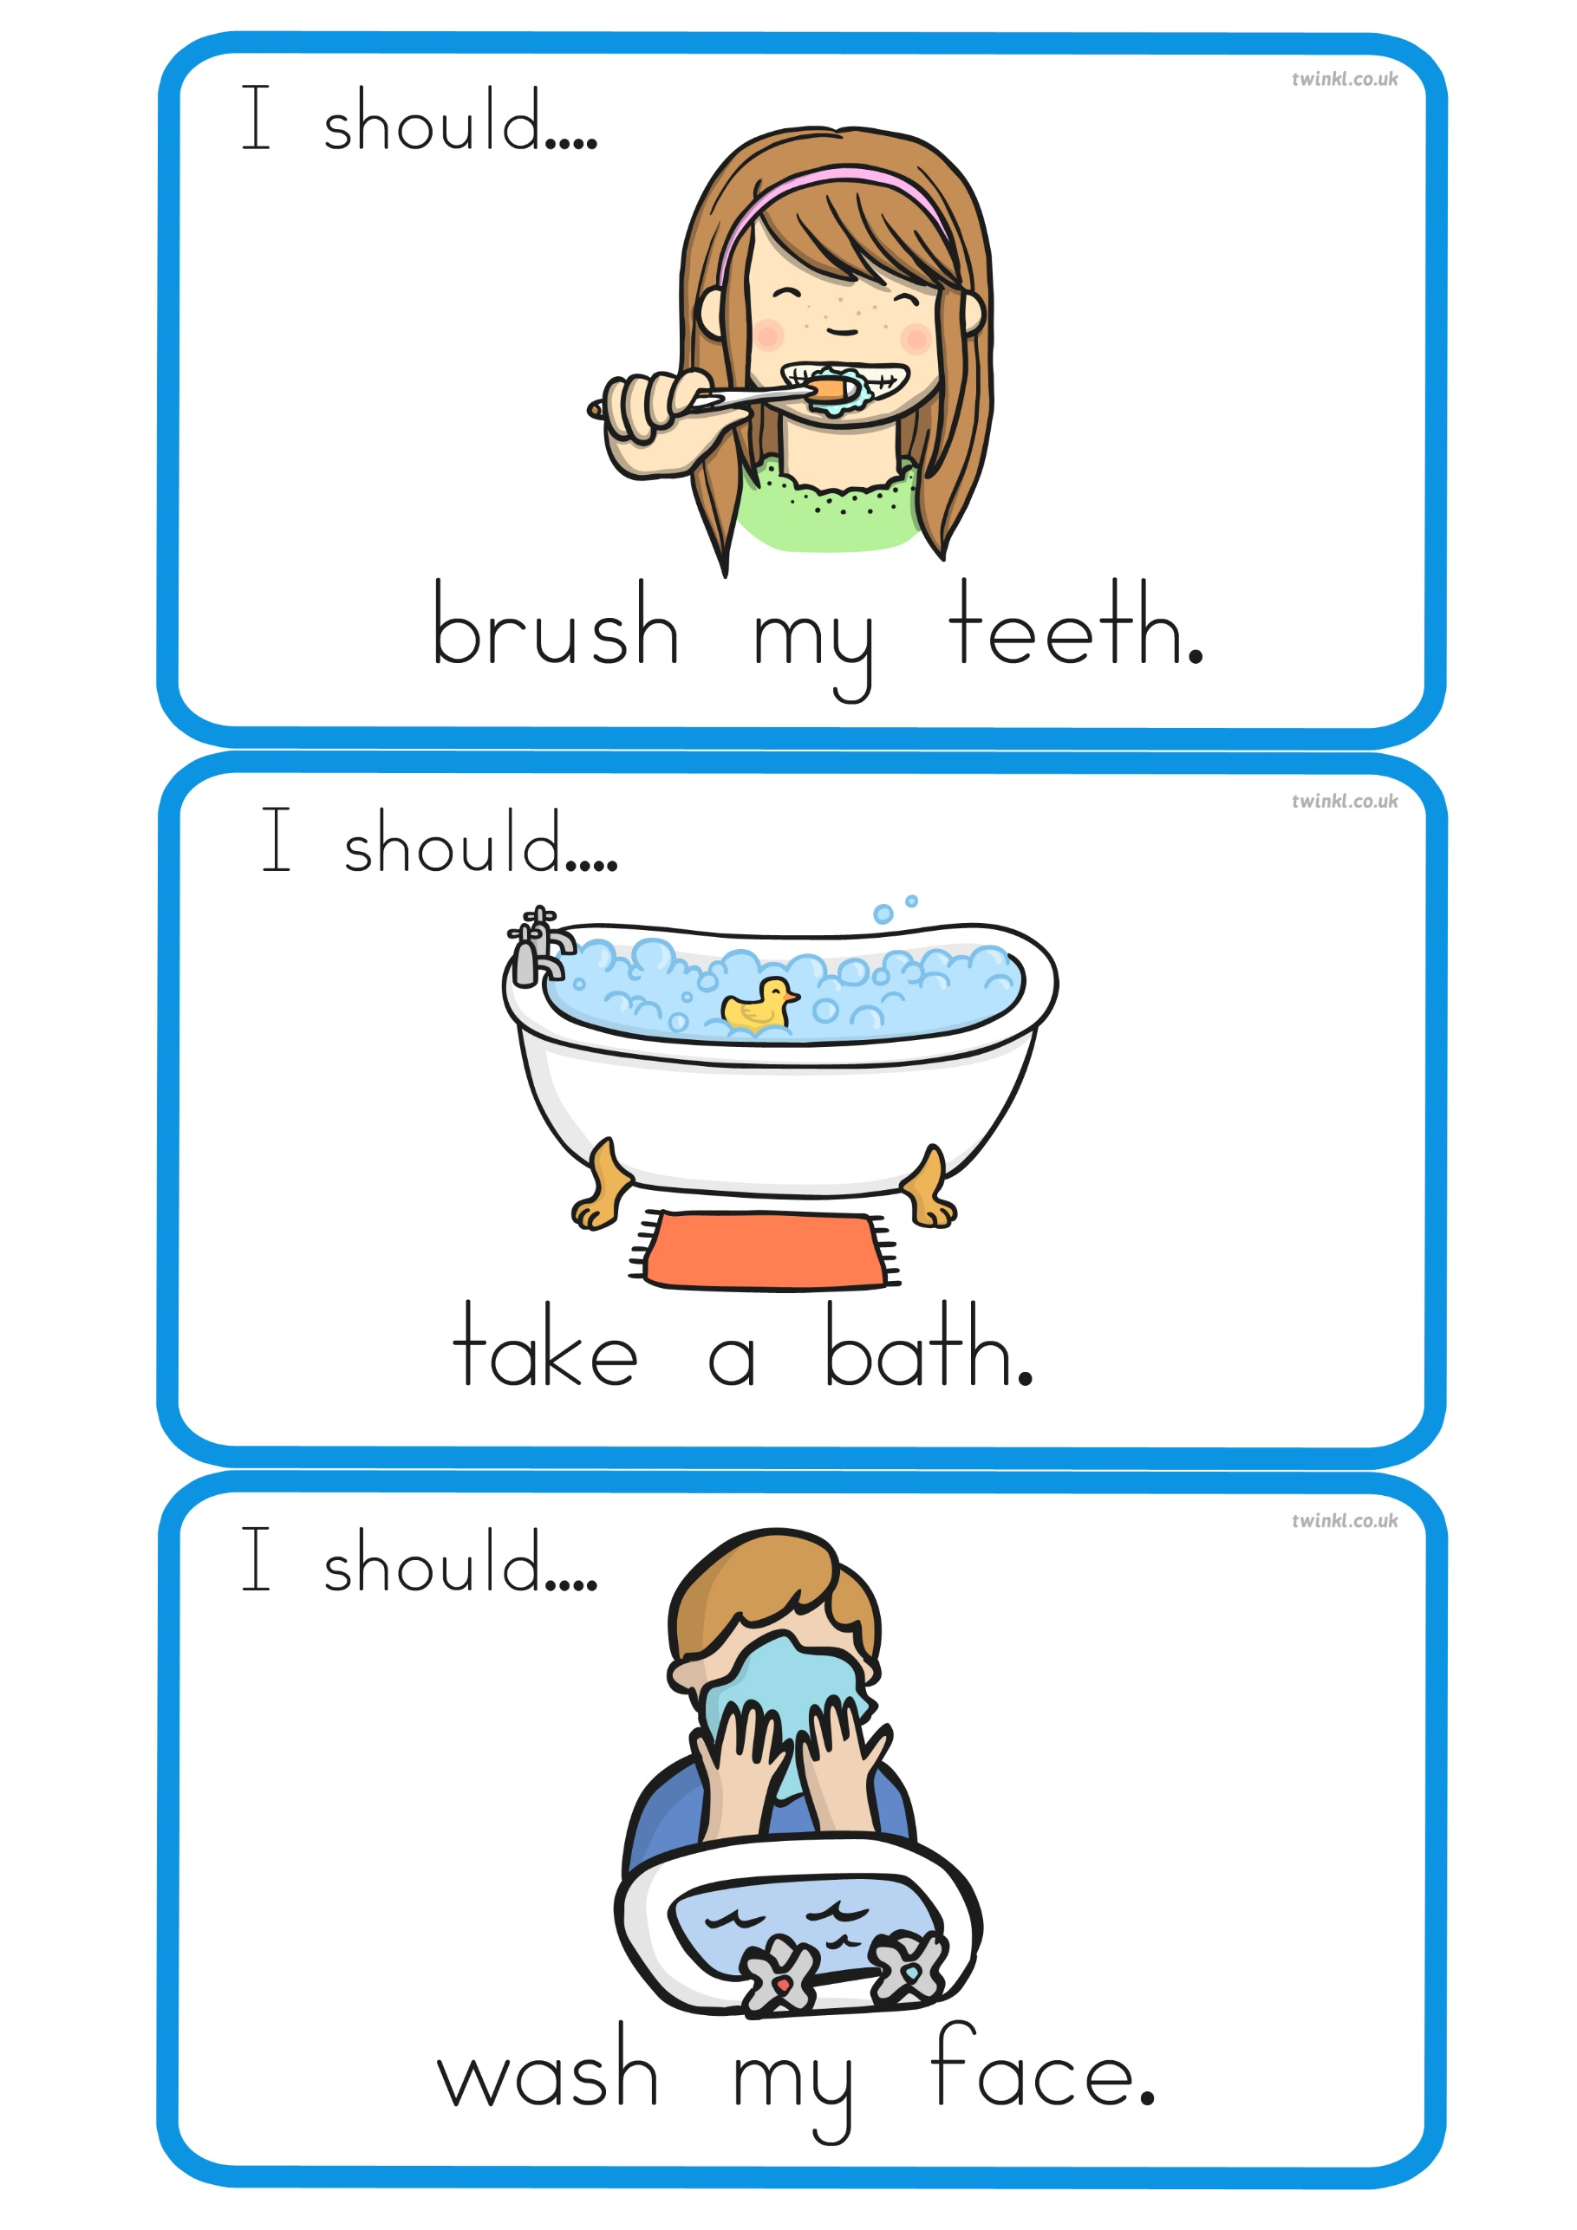
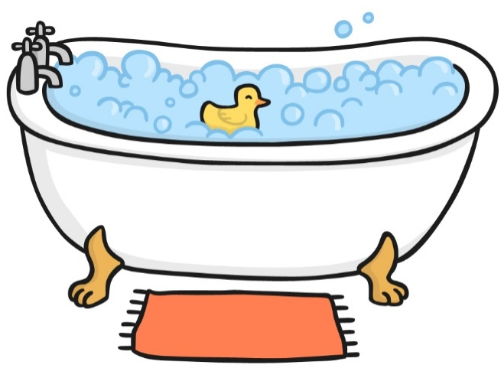
wash my face.
I should…
take a bath.
I should…
brush my teeth.
I should…
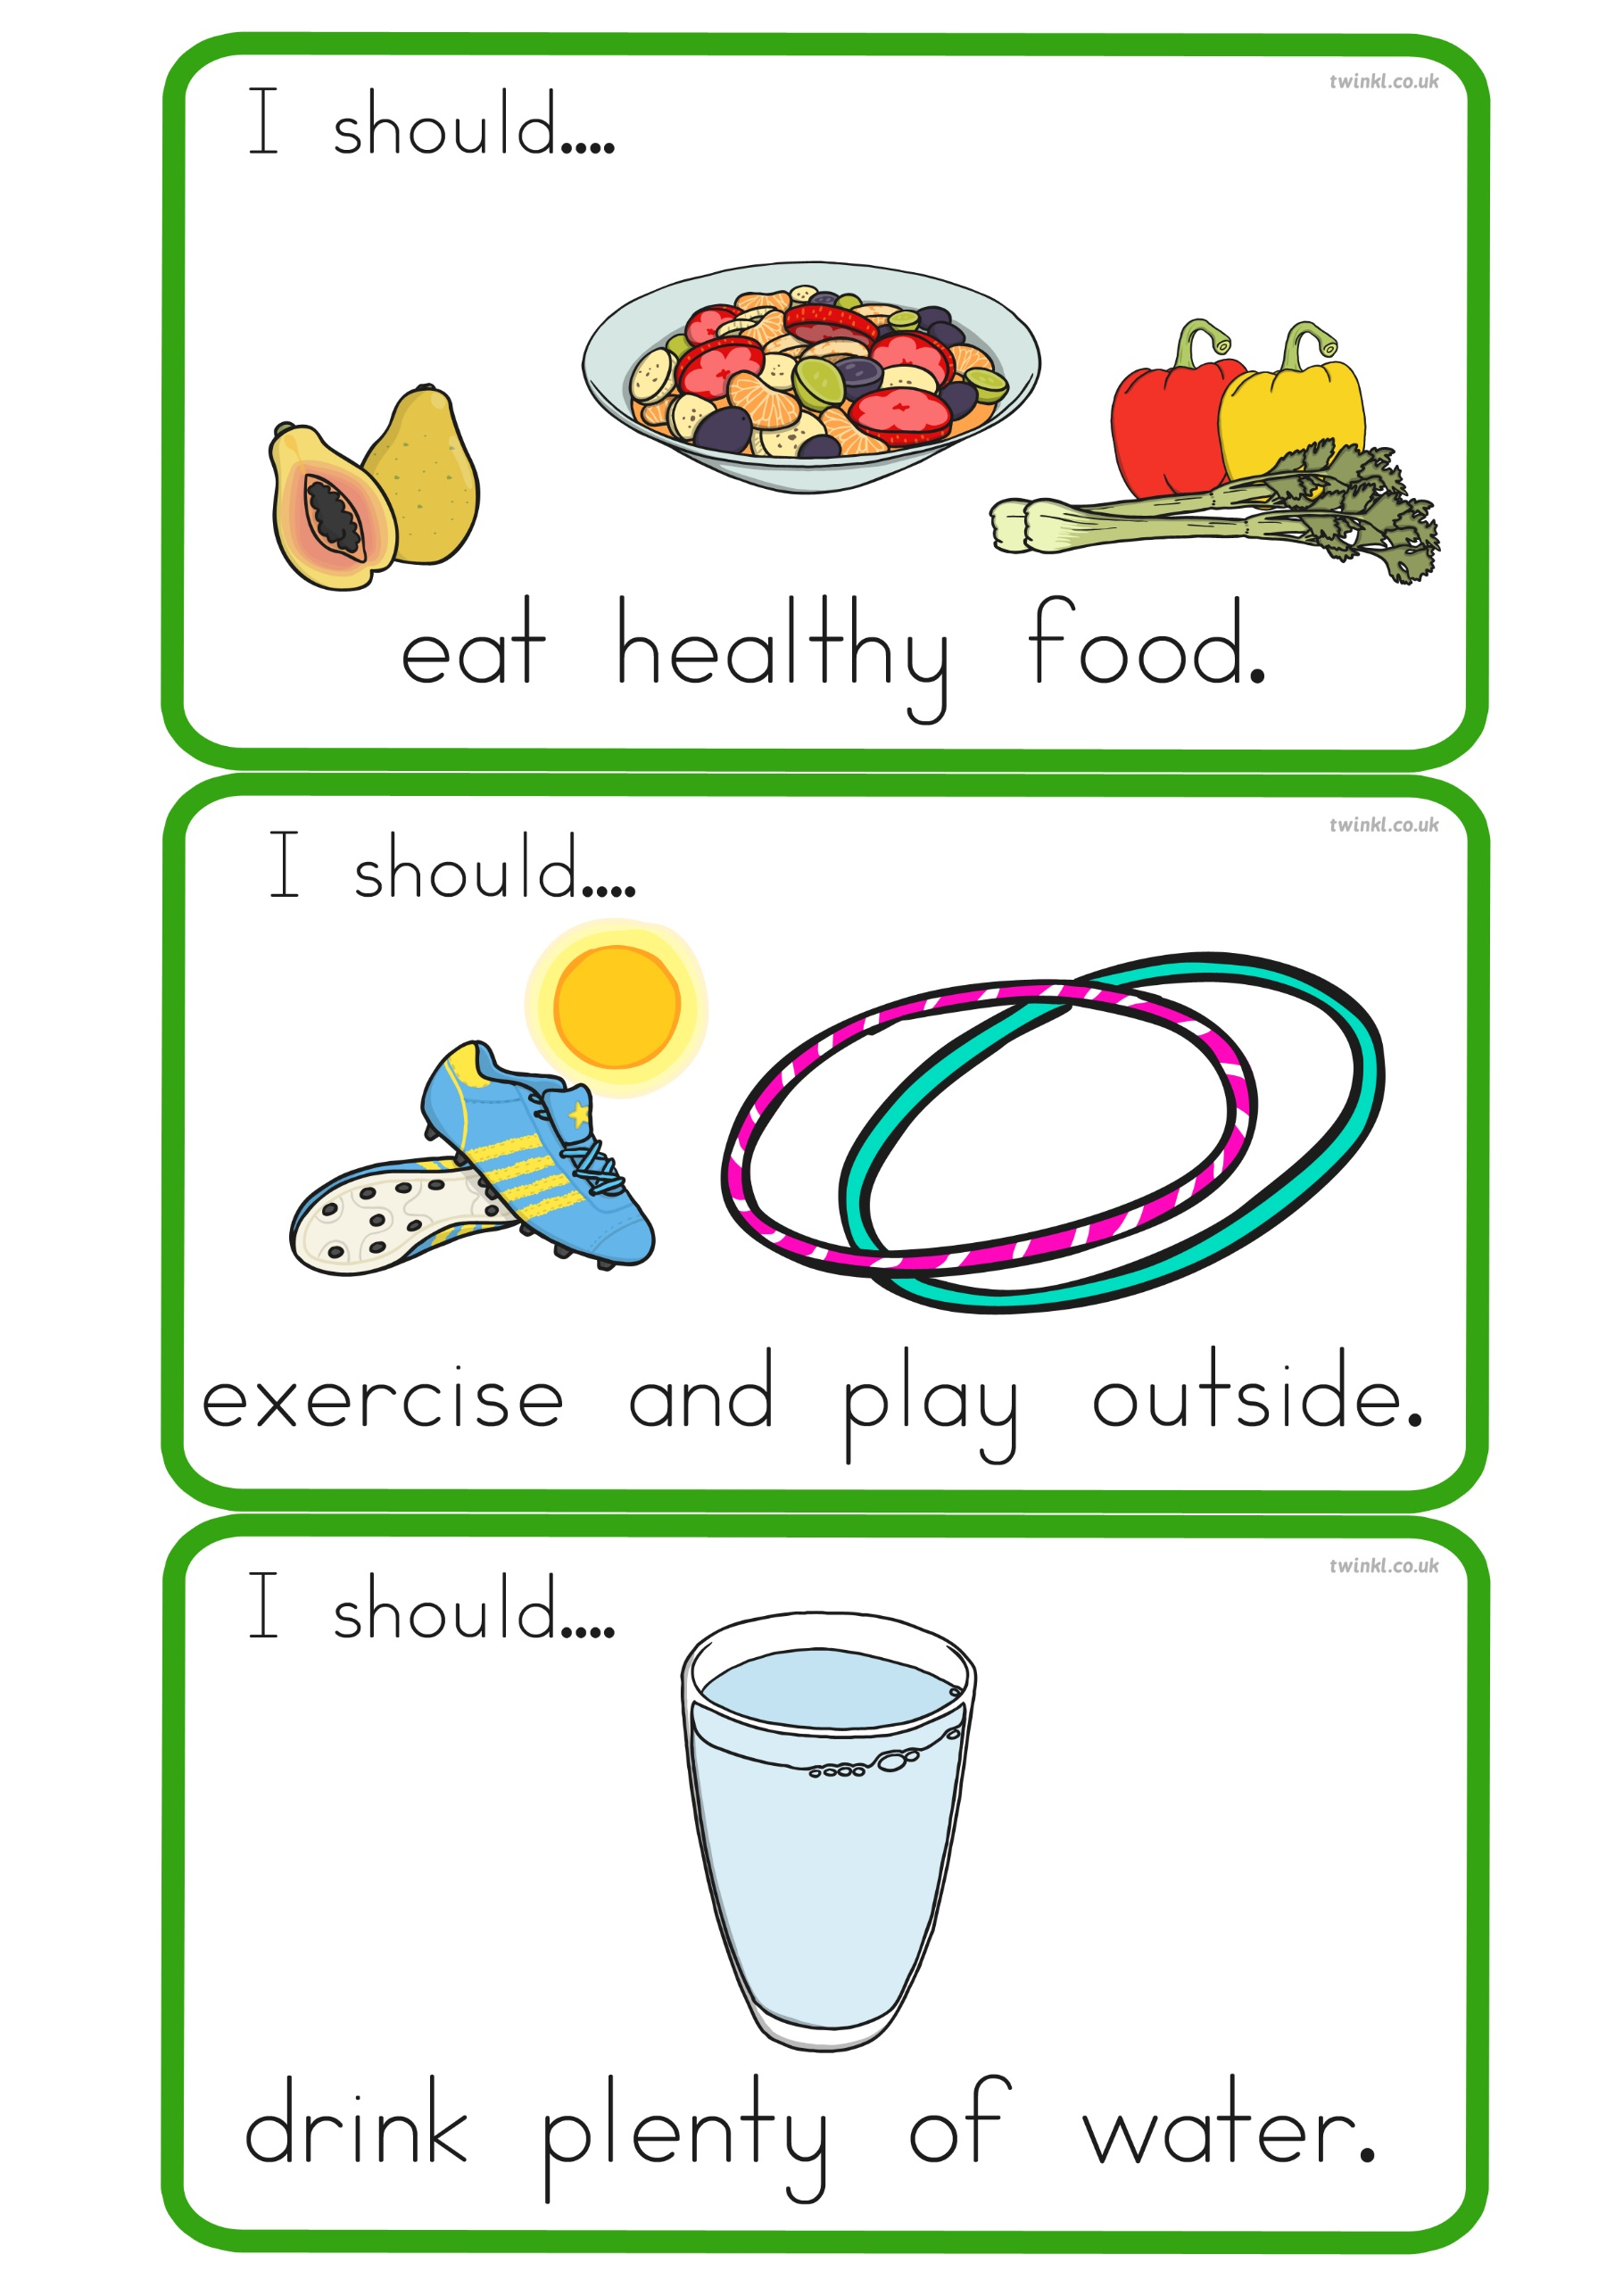
drink plenty of water.
I should…
exercise and play outside.
I should…
I should…
eat healthy food.
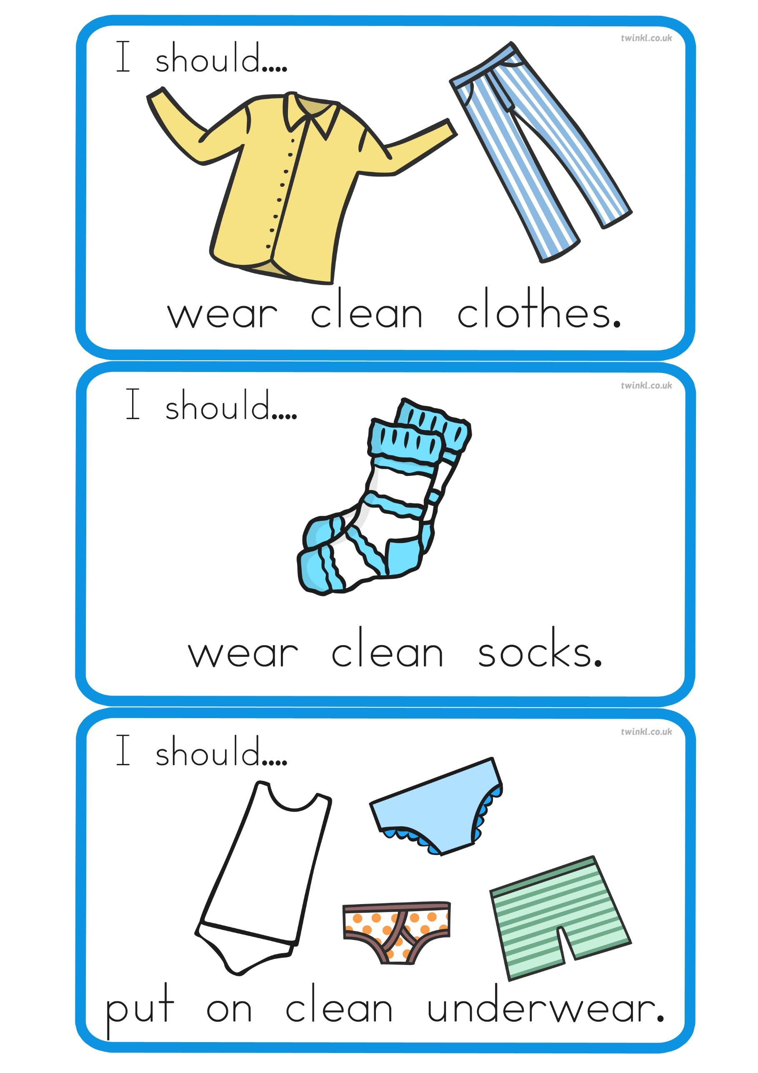
Put on clean underwear.
I should…
I should…
wear clean socks.
wear clean clothes.
I should…
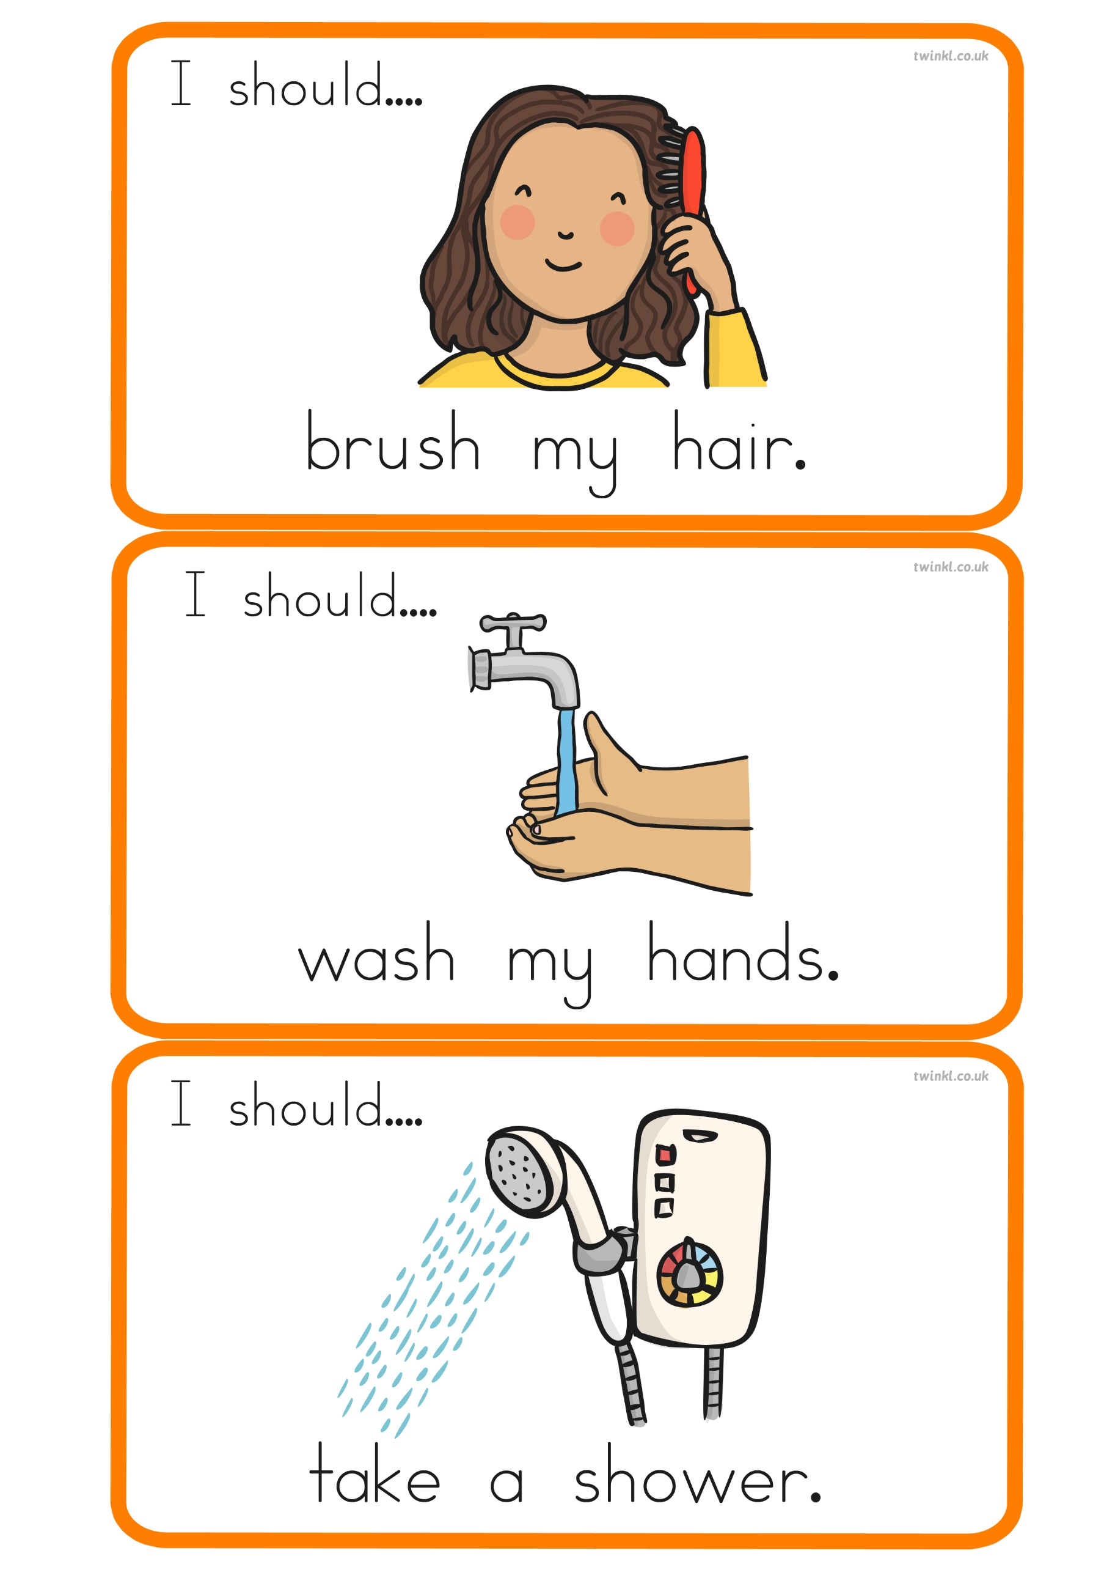
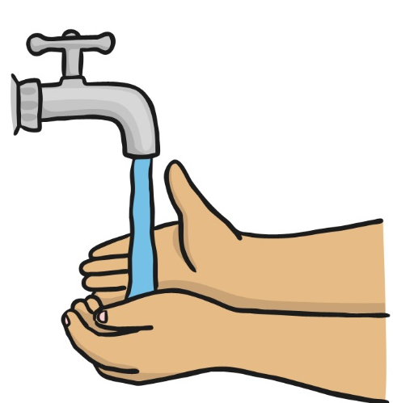
take a shower.
I should…
wash my hands.
I should…
I should…
brush my hair.
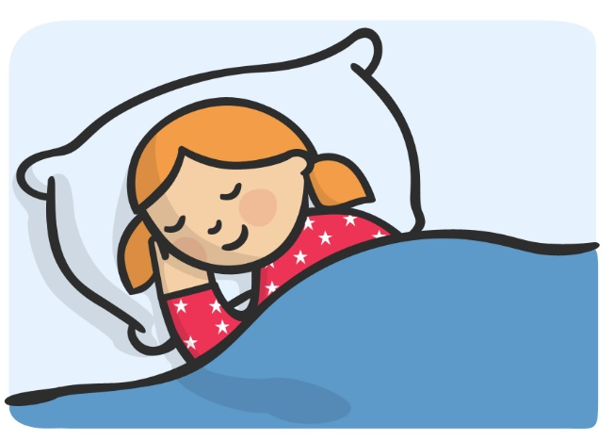
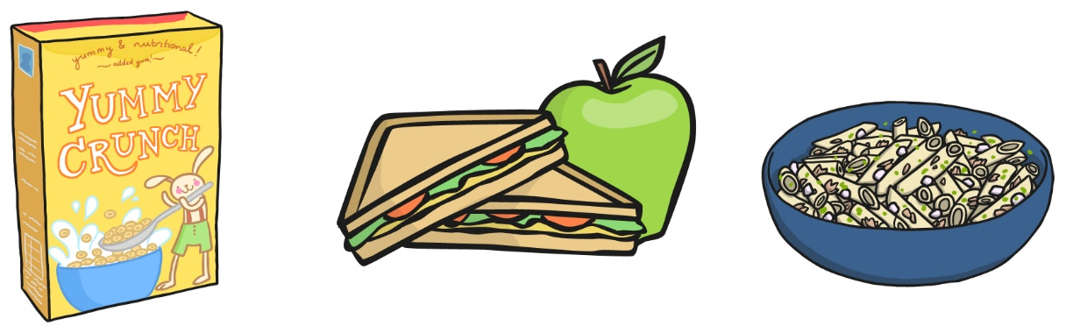
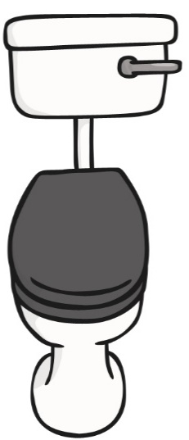
get plenty of sleep.
I should…
eat three meals a day.
I should…
go to the toilet.
I should…
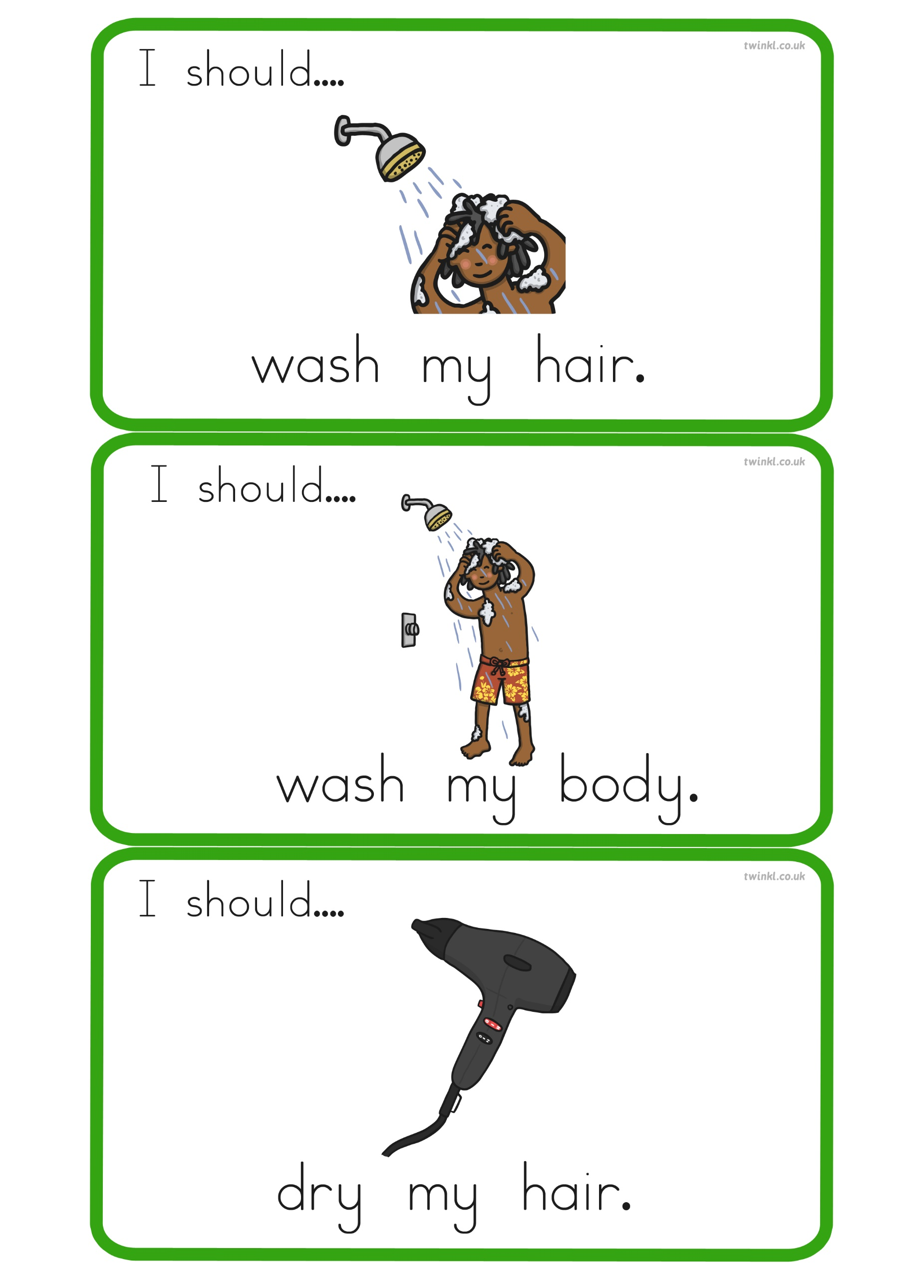
dry my hair.
I should…
wash my body.
I should…
I should…
wash my hair.

