 

**For more information, contact us at:**

**Think Wellbeing - Wigan**

Greater Manchester Mental Health NHS Foundation Trust

[**https://www.gmmh.nhs.uk/think-wellbeing**](https://www.gmmh.nhs.uk/think-wellbeing)

**Understanding and Coping with PTSD Course**



•         *Text should be in Ariel*

•         *Text should be no smaller than 12pt*

•         *Text should be in black*

•         *Sub-headings should be bold*

•         *Make sure you have your flyer or poster approved by the communications team before issuing it.*

-          Image box (see sketch) – *‘Insert your image here. If you require an image from the Trust’s photo library please contact the communications department’*

**What happens next?**

The course is currently delivered via Microsoft Teams by a CBT Therapist and Psychological Wellbeing Practitioner.

Up to 12 people may be invited to attend the course at any one time and invitations will be sent to the email address you provided at your initial assessment.

Around 48 hours before the course starts you will receive an email from “Web Forms” with questionnaires that we encourage you complete before the session start time.

**How long does the course last?**

The course consists of **5** weekly sessions, each session lasting **1.5 hours**. There will be one or two facilitators and each session will cover the following:

* Week 1 – Understanding and Coping with PTSD
* Week 2 - Threat System – Fight or Flight
* Week 3 – Trauma Memories
* Week 4 – Thoughts and Beliefs
* Week 5 – Coping Strategies, Moving Forward and My Plan for Recovery

**Will I have to talk about myself or share personal experiences with others?**

Put simply, no. The sessions are informal and relaxed, and we encourage that you don’t talk about your individual trauma.

**About Think Wellbeing - Wigan**

This information leaflet has been designed to prepare you for engaging with the Think Wellbeing service. It contains some information on what therapy is and what to expect, and some basic information on Cognitive Behavioural Therapy (CBT) along with some therapeutic exercises to complete whilst you are waiting for your therapy to start.

**What does psychological therapy look like in this service?**

National guidance recommends that treatment for PTSD should follow a "stepped care model.” This means that you are offered the least intensive and most appropriate form of therapy to meet your needs in the first instance. Our service offers Step 2 (low intensity) and Step 3 (high intensity) therapies; the level of intervention you receive is decided at your triage appointment. This may change once you start therapy but your therapist will always discuss things with you before any changes are made to your care.

We offer evidence based therapies to support people to overcome mental health difficulties. One of these therapies is called Cognitive Behavioural Therapy (CBT) - a type of talking therapy which is supported by the use of a wide range of information and self-help resources to help you understand and manage your symptoms better. CBT is aimed at reducing the severity and intensity of symptoms by changing the way you think and behave in certain situations.

**Preparing for Psychological therapy work**

Try completing your own thoughts, feelings and behaviours cycle. Start by recording the situation you were in (where were you? Who were you with? When was it?), then try breaking down your experience into three categories:

**Thoughts** – what thoughts ran through your mind in that situation?

**Feelings** – how did you feel in response to what you were thinking? e.g. happy, sad, angry, scared

**Physical Sensations** – what did you notice going on in your body?

**Behaviour** – what action did you take in response to thinking and feeling in this way?

Take a moment to notice how each component

part of the cycle affects the other.

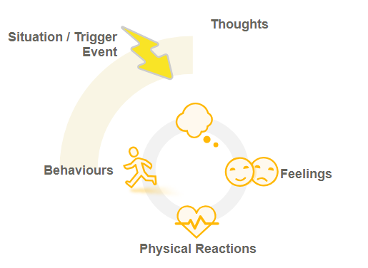

**Cognitive Behavioural Therapy**

A basic premised of CBT is that situations themselves do not cause us to feel and behave in certain ways, but it is how we interpret (think) about the situation, therefore changing the way you think is central to CBT. Your therapist will aim to create a shared understanding of your problem to help you to identify unhelpful thinking patterns and behaviours, which will then become the focus for change. It is important to understand that Steps 2 and 3 therapies are not a form of counselling – they are focused on the here and now and aimed at helping you make meaningful changes and better understand how your thoughts, feelings and behaviours interact. An example of this can be found below:

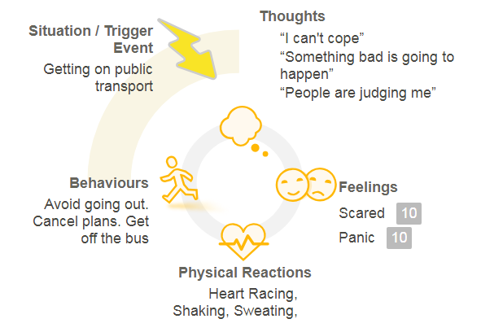

**What can I expect?**

People who have completed this course have reported: a better understanding of what PTSD is and how it affects you, improvements in mood and basic grounding techniques.

**“Learning about the background of PTSD and the physical effects on the body and my feelings was really helpful.”**

**“Very informative course with useful information it helped me to understand my feelings and difficulties.”**

**If you have opted for the PTSD Course…**

The Understanding and Coping with PTSD (Post-Traumatic Stress Disorder) Course is underpinned by Cognitive Behavioural Therapy (CBT). The main aim of the course is:

* To teach you about PTSD
* Learn new skills and techniques to help you cope with symptoms associated with PTSD
* Give you the foundations you need for later phases of PTSD treatment

This is not group counselling, we ask that you refrain from sharing details of what you’ve been through as this could trigger anxiety and distress in other attendees and yourself.

**Who is the course for?**

This course has been designed for anyone who wants to better understand their thoughts and feelings and learn ways to manage symptoms of PTSD.

**What will be expected of me?**

Making a commitment to attend **all** the sessions is important. You will be taught practical skills and techniques to manage your emotions and improve your wellbeing. An integral part of this course is about practicing these skills in-between sessions.

**If you are currently a witness in a criminal proceeding related to the trauma you are seeking help with please ask your therapist for more information.**