**For more information, contact us at:**

**Think Wellbeing - Wigan**

Greater Manchester Mental Health NHS Foundation Trust

**Lindamere Unit (South)**

Leigh Infirmary

The Avenue

Leigh

WN7 1HS

Tel: 01942 764450

**Wigan Life Centre (North)**

**South Building**

College Avenue

Wigan

WN1 1NJ

Tel: 01942 764450

**www.gmmh.nhs.uk/think-wellbeing-wigan**

**What will be expected of me?**

Making a commitment to engage with the programme by logging in, reviewing content and using tools on a weekly basis is important. You will be taught practical skills and techniques to manage your emotions and improve your wellbeing.

**What are the benefits of SilverCloud?**

* Available 24 hours a day, seven days a week
* An easy to use online website ONLY YOU can access
* Can be done at a time and place that suits you
* You can start the therapy straight away
* You will get weekly online support from your therapist
* You will have access to the system for a year after you’ve been discharged from the service
* It has been shown to be more effective than one-to-one therapy

People who have used the programme have reported: feeling more positive about themselves, improvements in mood, having the skills to deal with unhelpful thoughts, being able to manage stress and anxiety better and more active lifestyles.

***“The information was helpful and informative with regular input from the therapist who was equally just as helpful. I would recommend this service.”***

***“Now it's the end of the program I hardly feel anxious at all and I feel in a much calmer restful place, I'm thankful for the support I've received each week, it has really helped me understand who I am”***

**About Think Wellbeing - Wigan**

This information leaflet has been designed to prepare you for engaging with the Think Wellbeing service. It contains some information on what therapy is and what to expect, and some basic information on Cognitive Behavioural Therapy (CBT) along with some therapeutic exercises to complete whilst you are waiting for your therapy to start.

**What does psychological therapy look like in this service?**

National guidance recommends that treatment for anxiety and depression should follow a "stepped care model.” This means that you are always offered the least intensive and most appropriate form of therapy to meet your needs in the first instance. Our service offers Step 2 (low intensity) and Step 3 (high intensity) therapies; the level of intervention you receive is decided at your triage appointment. This may change once you start therapy but your therapist will always discuss things with you before any changes are made to your care.

All the therapies we provide are recommended and scientifically proven to be effective in treating mental health problems. One of these therapies is called Cognitive Behavioural Therapy (CBT) - a type of talking therapy which is supported by the use of a wide range of information and self-help resources to help you understand and manage your symptoms better. CBT is aimed at reducing the severity and intensity of symptoms by changing the way you think and behave in certain situations.

**Cognitive Behavioural Therapy**

A basic premised of CBT is that situations themselves do not cause us to feel and behave in certain ways, but it is how we interpret (think) about the situation, therefore changing the way you think is central to CBT. Your therapist will aim to create a shared understanding of your problem to help you to identify unhelpful thinking patterns and behaviours, which will then become the focus for change. It is important to understand that Steps 2 and 3 therapies are not a form of counselling – they are focused on the here and now and aimed at helping you make meaningful changes and better understand how your thoughts, feelings and behaviours interact. An example of this can be found below:

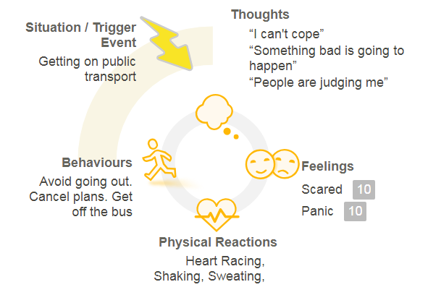

**If you have opted for the SilverCloud programme…**

Stress, anxiety and low mood often go hand in hand. We all experience moments of anxiety and low mood, but sometimes these periods can last for weeks or months. When experienced regularly we can start to view ourselves, the world and others negatively. We can get trapped in a vicious cycle of doing less, social withdrawal and self-criticism.

SilverCloud is a safe and secure online space offering personalised programmes to help people experiencing a wide range of mental and behavioural problems. Once registered, you can complete modules chosen by your own online supporter at your own pace, where and when it suits you. You’ll also have access to a variety of tools that help you with setting goals, problem solving and other practical life skills.

The programme is underpinned by Cognitive Behaviour Therapy (CBT), this is about the role which thoughts (cognitions) have on our feelings (affect) and actions (behaviour), and how they relate to each other. A basic rule of CBT is that situations themselves do not result in us feeling or behaving a certain way, it is how we interpret (think about) the situation which leads to this. Therefore, CBT aims to change negative thinking patterns, a key feature of depression and anxiety, which leads to changes in our feelings and behaviour.

**Who is SilverCloud for?**

SilverCloud is for anyone who wants to better understand their thoughts and feelings and learn ways to manage daily stress, anxiety and periods of low mood.

**Goal Setting**

Therapy is goal-oriented and your therapist will support you in moving towards your goals, however they need to come from you. You should take this opportunity to start thinking about your therapeutic goals, what do you want to achieve, work towards or change in your life? Goals are very personal. To help you think about your goals, ask yourself the following question:

***“If I am to commit to attending regular therapy appointments, what is it I want to achieve?”***

To help clarify your goal further, here is a useful check-list to use. Make sure your goals are SMART

**Specific** – be as specific as you can. For instance, the goal I want to feel better is not specific, what does better mean? If you were better what would your life look like?

**Measurable** – you need to know when you have achieved your goal. What is your predicted outcome? Can your goal be measured?

**Achievable** – is your goal achievable?

**Realistic** – is your goal realistic given your personal circumstances? Take into account your physical health, and resources you have available to you

**Time-limited** – how long are you going to give yourself to dedicate to achieving this goal?

Use space below to write down three therapeutic goals you want to work on in therapy.

1.

2.

3.

**Preparing for Psychological therapy work**

Try completing your own thoughts, feelings and behaviours cycle. Start by recording the situation you were in (where were you? Who were you with? When was it?), then try breaking down your experience into three categories:

**Thoughts** – what thoughts ran through your mind in that situation?

**Feelings** – how did you feel in response to what you were thinking? e.g. happy, sad, angry, scared

**Behaviour** – what action did you take in response to thinking and feeling in this way?

Take a moment to notice how each component part of the cycle affects the other.

