HOW TO USE AIDS SAFELY

Kettle Tipper

https://youtu.be/r-wOyE_lPc4

https://youtu.be/rEVgsyuTq2s

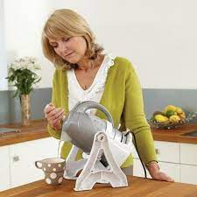

Weighted big grip Cutlery set

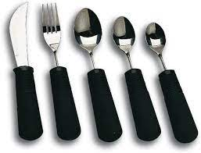
Jar Openers
Zyliss Strong Boy Jar Opener Review - YouTube

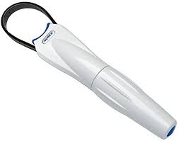
Dycem Jar Opener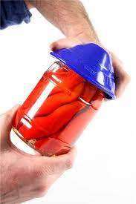

Culinaire One Touch Can Opener Review - YouTube
Culinaire Magipull Ring Pull Opener
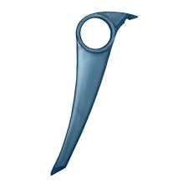

Opens everything!!!
Open Sesame (musthaveideas.co.uk)

Easy grip cups
Amazon.co.uk : arthritis cup easy grip
Non-slip mat
Dycem® Non-Slip Mat - Circular Review - YouTube
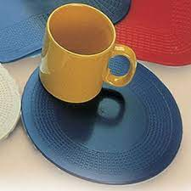
Spikeboard
M79849 NRS Kitchen Spread Board With Spikes - YouTube
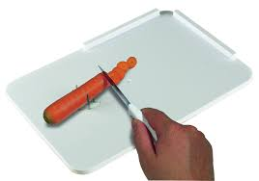

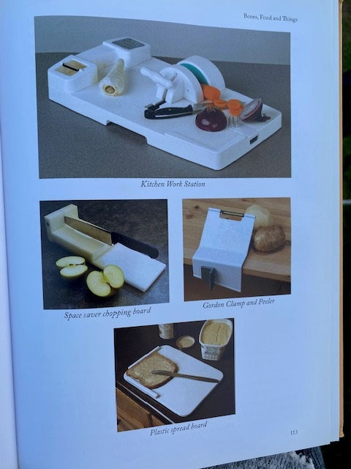

NRS Healthcare Sock/Hose Aid
Sock Aid https://youtu.be/Us0bcyyoAaE
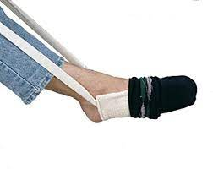
NRS Healthcare stocking aids - gutter style
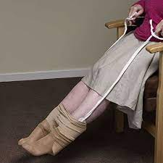
Shoe Horn
Deluxe Chrome Shoe Horn - YouTube

Amazon.com: The Wright Stuff WingsPants Small Dressing Aid for Pants : Health & Household Trousers dressing aid
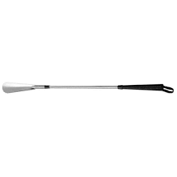

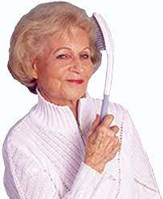

Lifestyle Long handled brush

Bathroom Aids
bottom wiping aids - Google Search

Long handled sponge
Helping Hand Long Handled Buff Sponge | Sponges & Washers | Manage At Home
Search - NRS Healthcare Pro – long handled sponge
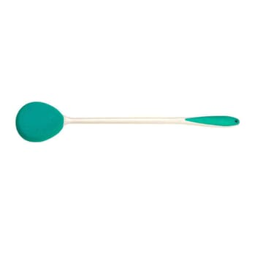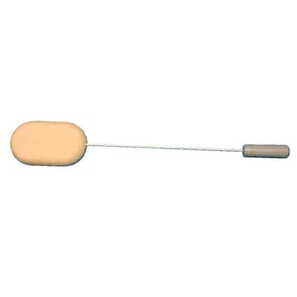
Combi Grabber
NRS Combi Grabber Demo - YouTube
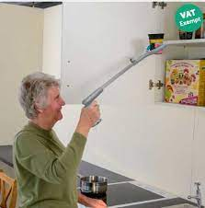
Tap turner
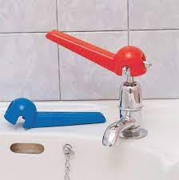
Medeci® Crystal & Crosshead Tap Turner - YouTube

Make up applicator
UNIE® Eyeliner Stencils, Winged Eyeliner Tool, Mascara Shield, Multifunctional Silicone Eyeshadow Applicators, Perfect for Beginners in Makeup : Amazon.co.uk: Beauty

Amazon.co.uk : radar key – access to disabled toilets

Amazon.co.uk : pen grips for adults pen grips

Ergonomic Rollerball - STABILO EASYoriginal - Right-Handed - Dark Blue/Light Blue : Amazon.co.uk: Stationery & Office Supplies – easy grip pen

Bath Step https://youtu.be/-kW5wXP4BhA
(ensure try equipment without shoes and socks on)
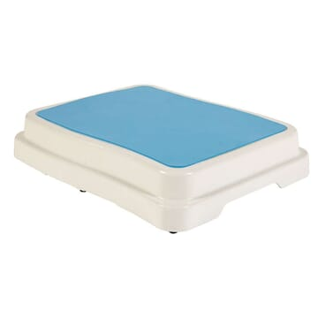
Bath Board
https://youtu.be/hpq0s_BzTYQ

https://youtu.be/zoEDPoI2x-c (fitting and using)
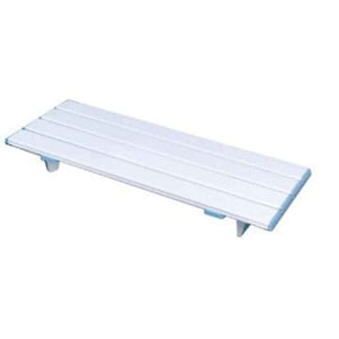
Key turner
Key turner - YouTube
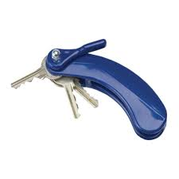

Radar key for disable toilets
https://www.incontinencechoice.co.uk/easy-turn-key-for-disabled-toilets.html?gclid=EAIaIQobChMI8tSn19Tv_QIVdIBQBh18-Q7VEAQYBCABEgLbLvD_BwE

Button hooks Using a Button Hook Device - YouTube How To Use A Button Hook (With Zipper Pull) - YouTube 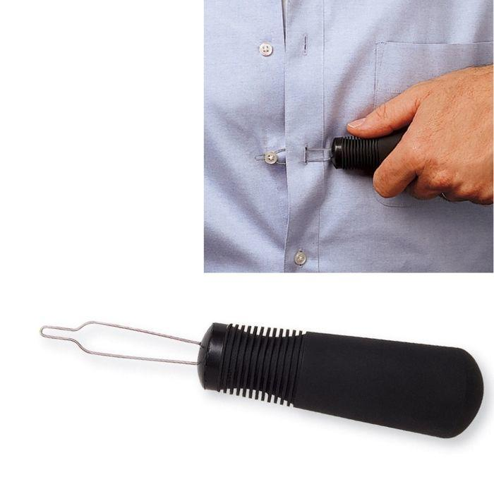
Furniture risers
Furniture Risers - YouTube
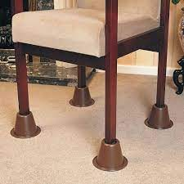

Standing mat
https://www.salonsdirect.com/hair-tools-anti-fatigue-mat-square-black?gad_source=1&gclid=EAIaIQobChMI-YzdgvWChQMV7phQBh2ghwU_EAQYAiABEgJoB_D_BwE

Other videos
https://www.youtube.com/watch?v=dbFCRpoBk-M Bed Raiser

https://www.youtube.com/watch?v=oIanuBdIkew Chair Raiser

https://www.youtube.com/watch?v=hpq0s_BzTYQ Bath Board

https://www.youtube.com/watch?v=-kW5wXP4BhA Bath Step

https://www.youtube.com/watch?v=xFsT9QlHcFU Bath Lifter

https://www.youtube.com/watch?v=Sf5_BF3Mg7Y Commode

Stadium Seat
https://www.amazon.co.uk/dp/B072MFMQC9/ref=cm_sw_r_oth_api_glt_fabc_BMMSCGFENXRAJ7YHCNPQ

COOKFULLNESS BOOK
https://www.amazon.co.uk/dp/1913568792/ref=cm_sw_r_oth_api_glt_fabc_ABP6BBFV2NK239WERCC9

Yolev 6 Pieces Stainless Steel Circular Knitting Needles Set 10 mm 8 mm 6 mm 5 mm 4 mm 3 mm Diameter Double Pointed Metal Knitting Needles Set for Making Sweater Shawl Scarf https://gbr01.safelinks.protection.outlook.com/?url=https%3A%2F%2Famzn.eu%2Fd%2F0SxtbXU&data=05%7C01%7Cdionne.carroll4%40nhs.net%7C1d30ee0cea744a17305508dae19d7b0c%7C37c354b285b047f5b22207b48d774ee3%7C0%7C0%7C638070363727023651%7CUnknown%7CTWFpbGZsb3d8eyJWIjoiMC4wLjAwMDAiLCJQIjoiV2luMzIiLCJBTiI6Ik1haWwiLCJXVCI6Mn0%3D%7C3000%7C%7C%7C&sdata=6J%2F%2FCAW31uS38l%2BVuNzqurBuEcIgrRrRtc9yif6zL4c%3D&reserved=0

LotFancy Playing Card Holder For Kids Little Hands Plastic Poker Holder Case Hands Free Game Card Stands For Canasta Uno Extreme Waddingtons, 4 PCS https://gbr01.safelinks.protection.outlook.com/?url=https%3A%2F%2Famzn.eu%2Fd%2F83XzWr4&data=05%7C01%7Cdionne.carroll4%40nhs.net%7C5d1da5c6256d4c27cc6908dae19d8645%7C37c354b285b047f5b22207b48d774ee3%7C0%7C0%7C638070363910188983%7CUnknown%7CTWFpbGZsb3d8eyJWIjoiMC4wLjAwMDAiLCJQIjoiV2luMzIiLCJBTiI6Ik1haWwiLCJXVCI6Mn0%3D%7C3000%7C%7C%7C&sdata=YsB7dRdjybuEw5StiEi9iSyCkqmLSi1%2FSPbkTH%2BYdxo%3D&reserved=0

